QUESTIONS ARISING FROM 23rd MEETING (12 Oct 2012)

We looked at the 5th poem in Book 1of Ovid’s Amōrēs, the work which he published in and which established his reputation as one of Roma’s leading poets. This particular poem stands out for its focus on the physical side rather than the psychological. The poet is about to take his siesta in a partially darkened room when his girlfriend, Corinna, enters in an unfastened tunic and with disheveled hair,. He overcomes her feigned resistance to remove the tunic entirely and they make love. The culmination is delicately passed over (with the phrase cētera quis nescit?) but only after Ovid has described his lover’s charms in detail. The text, with commentary, vocabulary, critical essay, illustrations and a recorded reading can all be accessed on the Dickinson College site at
http://dcc.dickinson.edu/ovid-amores/amores-1-5 For those who want to study the poem off-line, the handout we used at the meeting is separately attached.

Aestus erat, mediamque diēs exēgerat hōram;
apposuī mediō membra levanda torō.
pars adaperta fuit, pars altera clausa fenestrae,
quāle ferē silvae lūmen habēre solent,
quālia sublūcent fugiente crepuscula Phoebō 5
aut ubi nox abiit nec tamen orta diēs.
illa verēcundīs lūx est praebenda puellīs,
quā timidus latebrās spēret habēre pudor.
ecce, Corinna venit tunicā vēlāta recīnctā,
candida dīviduā colla tegente comā, 10
quāliter in thalamōs formōsa Samīramis īsse
dīcitur et multīs Lāis amāta virīs.
dēripuī tunicam; nec multum rāra nocēbat,
pugnābat tunicā sed tamen illa tegī;
cumque ita pugnāret tamquam quae vincere nōllet, 15
victa est nōn aegrē prōditiōne suā.
ut stetit ante oculōs positō vēlāmine nostrōs,
in tōtō nusquam corpore menda fuit:
quōs umerōs, quālēs vīdī tetigīque lacertōs!
forma papillārum quam fuit apta premī! 20
quam castīgātō plānus sub pectore venter!
quantum et quāle latus! quam iuvenāle femur!
singula quid referam? nil nōn laudābile vīdī,
et nūdam pressī corpus ad usque meum.
cētera quis nescit? lassī requiēvimus ambō. 25
prōveniant mediī sīc mihi saepe diēs.

There is a general problem with Latin love poetry of deciding how much is autobiographical and how much simply the poet’s imagination. One of us suggested that this poem reads like a classic male fantasy and, although Ovid’s fame probably ensured that he hand no shortage of real girlfriends, this work was published before he achieved star status. There is also some controversy over just how permissive Roman society was a this time though it’s certain that woman had more freedom to take lovers for themselves than under the early republic and the decline in mātrimonium cum manū (marriage in which the father’s legal guardianship over his daughter was formally passed to the husband) put married woman in a stronger position. The Emperor Augustus actively tried to restore older sexual mores and Ovid’s eventual exile is generally thought to have been the result both of the general tone of his poetry and of some kind of involvement with the emperor’s own daughter or grand-daughter (both called simply Julia).

We discussed Latin equivalents for the terms prostitute and courtesan. Although dictionaries generally give both English words as translations of meretrix, this term was milder than scortum so this pair of Latin words perhaps approximate to the courtesan/prostitute distinction in English. It’s also likely that the Greek word hetaira (literally `female companion’), which comes very close to the connotations of courtesan, was used by educated Romans in the Latin form hetaera in the same sense. We also discovered the word ambūbāia, rather priggishly defined in Lewis and Short as one of `a class of Syrian girls in Rome who supported themselves by their music and immorality’.

As our new member, Alex, is an ethnomusicologist, we discussed the corresponding term – ethnomusicologista (on the analogy of Latinista) is perhaps the best, though some preferred the snappier ethnomusicologus. Alex is researching breakdancing as street performance in Hong Kong, which is known in Cantonese simply as gaaimou (街舞) so could be saltātiō (-iōnis, f) viāria or, following the English more closely, saltātiō fractōria (John’s original suggestion of frangōria is dubious). Pat pointed out that the Latin via is actually cognate with the English way, as is pēs (foot)

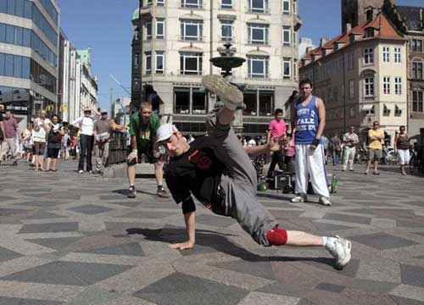

with path. Also on the general topic of movement, someone wanted a word for horseshoe, which is solea ferrea (literally iron sandal; horseshoes in the later sense of metal hoops nailed to a horses feet were unknown in classical times, but animals were sometimes fitted with sandals which could be put on and taken off as with humans.). The word faber referred in classical times specifically to the blacksmith, a lot of whose work was the shoeing of horses, but in Roman times it was a general word for craftsman.

On the food front, we discussed salad, for which the dictionaries have acētāria (-ōrum n.pl), though pat and Stefan thought a form like lattuca (connected with lactūca, lettuce) was used in the Middle ages. Pat also believed that the English word salad (derived from the Latin for salted) was once used to mean lettuce (the OED says this use of the word is `dialectal and American’ and just gives 19th century example). condiō means both season (as a verb) and pickle (verb), whilst the noun condimentum is spice or seasoning. For picnic, there is cēna subdiālis (`open-air dinner’) barbecue might be expressed rathe clumsily as cēna subdiālis carnis assae (`roast meat picnic’).Traupman has in crāticulā assāre (`roast on a little grid-iron’) as the verb barbecue, so, as in hong kong we often prefer to use BBQ forks, we could say also in furcā (? furculā?)assāre. The –ul- element signifies a diminutive and serves to distinguish an eating fork from a pitch-fork. The BBQ one is in between in size so it’s uncertain which word should be chosen!

It was agreed that after so many discussions of words connected with food we needed to put the words we’ve come up into proper order, At the moment, Stefan has a hand-written Latin –German list and this needs to be combined with information in the QUESTIONS ARISING files to produce a consolidated English-Latin document.

At the end of the evening Pat told us about his travels in Siberia and also provided more details from his vast store of knowledge on the history of HK and Macao. Only three of the old imperial statues in HK survived the war and Japanes occupation, one of them being that of Queen Victoria (now in Victoria Park0 which was brought back from Tokyo where it narrowly escaped being melted down for use in armaments manufacture? He explained that the Portuguese had established themselves on Lantau fron 1514 to 1521, when they were chased off by the Chinese government. They were also for a time using St. John’s Island off Macao as a base but occupied Macao itself when the Chinese sought their services against pirates in 1540-41, There was an agreement covering this but not providing for actual cession of territory and Chinese officials probably remained resident there until they were forced out after the British took Hong kong. The Portuguese governor at the time, João Maria Ferreira do Amaral,
who was killed by Chinese villagers when out riding, still has a street named after him but the Chinese government ordered the removal of his statue after regaining control of the territory.

QUESTIONS ARISING FROM 24th MEETING – 16 NOVEMBER 2012

Tanya brought along a partly finished mobile consisting of winged phallic shapes in embroidered felt – prototypically masculine objects in a feminine medium. This was an artistic project she’d had the idea for some years earlier, inspired by a Roman tintinnābulum (bell, bell-set) at the British Museum, which would probably have been hung near the door of a Roman house to ward off evil influences.

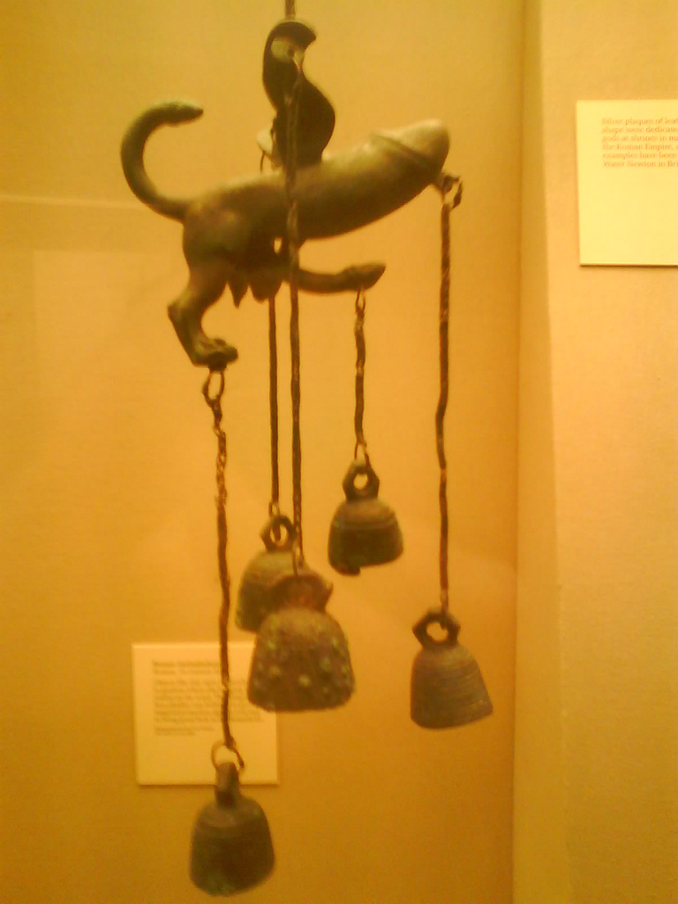

The Romans also made extensive use of phallus-shaped amulets (often winged) which were hung round children’s necks to protect them from the evil eye. A protective (`apotropaic’) talisman of this kind was known as a fascīnum (connected with the word fascinātiō, meaning `bewitching’). One or more of them were placed inside the bulla, a pouch or locket worn on a chain round a boy’s neck, and made of gold if he came from a wealthy family. The bulla was set aside when a boy came of age but might be used again if he was thought particularly likely to become an object of jealousy, as in the case of a conquering general awarded a triumph. The word bulla could also be used for other round objects, in particular bubbles. It was employed also for the round seal tied to important documents issued by the Pope –hence the phrase `Papal Bull’ came to be used of the document itself.

Tanya holds the controversial view that the adoption of the cross as a Christian symbol might have been conditioned by the shape of some of the fascīna (see the illustration below) and enabled people to change their religious allegiance while still keeping something fairly familiar around their necks:
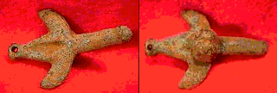
The use of the cross was obviously suggested in the first palace by the crucifixion but it was not immediately adopted as the religion’s primary symbol, early Christians preferring to use a fish, since the Greek for this (ichthus) was an anagram of Iēsous Christos Theou (h)Uios Sōtēr (`Jesus Christ son of God, Saviour’).

The use of phallic symbolism – whether stylized or graphically realistic – is common in many cultures. We mentioned the Herms of ancient Greece - statues of the God Hermes consisting normally of a square pillar with head and penis. Many Athenians had these outside their home and their desecration on the eve of the 415 expedition to Syracuse caused a major scandal. The shivalinga of Hinduism can still, of course, be seen all over India. The Romans themselves frequently had a statue of the phallic deity Priapus in their gardens, as a warning of what would happen to thieves or trespassers and a collection of generally obscene (and rather difficult) Latin poems about him, the Priapea, is available on-line at http://libri.freenfo.net/2/2000052.html

We also tried to determine whether penis is a neutral term (i.e. neither obscene like mentula nor a euphemism like membrum virile or digitus impudīcus). James Adams’ The Latin Sexual Vocabulary (substantial parts of which are available at http://books.google.com.hk/books?id=GDP9VHGbF1AC&dq=Latin+Sexual+vocabulary&pg=PP1&ots=_RvZIKyt2Y&sig=LkHShJM1IM2zOEUjf5jcSnOPfJU&hl=zh-TW&sa=X&oi=book_result&resnum=1&ct=result#PPP1,M1 ) does not help as it is only concerned with cataloguing taboo terms.

We decided on the straightforward phallus pinnātus for `winged phalllus’ (another word for `winged’ is alātus but this was only used in poetry). For the material felt itself, Pliny the Elder has lāna coācta (`forced wool’ – referring to its production by compression) and the adjective coāctilis, -e (used also as a noun, mainly in the plural – coāctilia, -ium n.) presumably developed out of this. The word feltrum is medieval. Middle Ages. Ducange’s 17th century Glossarium mediae et infimae Latintatis (http://ducange.enc.sorbonne.fr/), cited on Morgan and Tunberg’s neo-Latin word list (http://millie.furman.edu/morgan/adumbratio.htm) quotes a 1277 letter from Edward I of England requiring the Jews (whom he later expelled from his kingdom) to wear a yellow felt badge. In 1315, Marco Polo (also cited by Morgan and Tunberg) used feltrum in a description of tents (Mongolian yurts). There is a derived adjective filtreus, -a, -um.

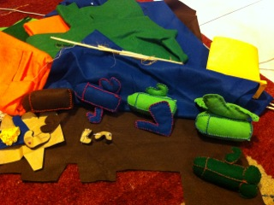
We also read the dialogues on Halloween/Lemuralia (see VOCABULA ET IUNCTURAE) which included an extract from Petronius’s Satyricon. Pat believed that only about a third of this `novel’ by a favourite (and later victim) of Nero has survived and that much of what we have has been preserved through quotation by grammarians. Later checking revealed that scholars are unsure exactly how long the original was. The werewolf anecdote is from the best-known section – the Cēna Trimalchiōnis (`Banquet of Trimalchio’), which satirises a rich freedman giving an ostentatious and vulgar dinner party.

Pat also explained that the Latin for werewolf, versipellis, literally means `one whose skin is turned;, referring to the belief that a werewolf in his human form had fur on the inside of his skin. Medieval writers used the Greek loanword lycanthropos (`wolf-man’), which become lycanthrope in French.
The story’s reference to the centurion urinating around his clothes before turning into a wolf prompted mention of the English verb stale, which means urinate but is only used of horses! Human urine was used in the dying and cleaning of cloth in Roman times and, according to Suetonius, the emperor Vespasian, despite objections from his son Domitian that this was an unworthy source of revenue, placed a tax on the urine pots at street corners where people were invited to deposit the liquid for collection!

The dialogue also includes mention of the novella De Bello Lemures, or the Roman War against the Zombies of Armorica and this occasioned a search for a better term for zombie than lemur (a malevolent ghost). Although a corpse is brought back to life in one scene in Apuleius’s novel Metamorphoses (or The Golden Ass), written on the 2ndd century A.D., no special term is used and so we fell back on corpus reanimātum

We also talked briefly about Seneca the younger, who, like Petronius, had to commit suicide after being accused of treason against Nero. His philosophical writings include some greatly admired passages, such as the assertion of the humanity of slaves but Seneca has been frequently accused of not putting his principles into practice. His Apolocolocyntosis Claudii (`Goudification of Claudius’), a satire on Nero’s predecessor, seems to have been intended to curry favour with the new emperor, who had been his student, and there was also a claim that his recalling of loans made to British nobles was one of the factors precipitating Boudica’s rebellion.

On the vocabulary front, it was pointed out that the family of words mīrābilis, miror etc. do not have the positive connation of English `admire’, `marvelous’ etc, but just indicate strong surprise. Reference was also made to onomatopoeic words for animal cries (like ululō, howl). There are lists of these at http://www.hs-augsburg.de/~harsch/Chronologia/Lspost02/Suetonius/sue_anim.html, and (with pictures in a list intended for use by children) http://www.learnlatinlanguage.com/DEMALPH.HTM#ALPHABET . There is a quiz on some of the words at http://www.sporcle.com/games/Chunklets/polsilvvva
QUESTIONS ARISING FROM 25th MEETING - 7 DECEMBER 2012/12/14

We spent time considering the translations for a dictum of Indian philosopher and mystic Jeddu Krishnamurti: `The primary cause of conflict is escape – escape through ideas’. John described Krishnamurti himself as a guru figure (he was certainly taken up and trained to be such by Annie Besant and her fellow Theosophists to be such - see the biography at http://en.wikipedia.org/wiki/Jiddu_Krishnamurti ) but Kristina argued that he would probably have preferred to have described himself simply as a `freak’! The meaning of his sentence appeared to be that people’s lack of satisfaction with the way they were led them to entertain ideas for change which then brought them into conflict with people with different ideas. However, this seems to contradict Krishnamurti’s own advocacy of a `revolution’ in people’s thinking.

The translations offered were:

causa iurgiōrum movēns fuga est – fuga vērō per sēnsās (Gregory)

iurgi causa prima fuga est- per ideis(?) fuga (Eleni)

primum movens conflicti fuga est - fuga idearum? (Don)

causa principalis iurgiorum est fuga – fuga vero per nōtiōnēs. (John)

Pat felt that fuga could only refer to physical flight and suggested ēvāsiō as an alternative, but in fact both words are defined primarily in physical terms and both could be used figuratively. Most of us finally settled on the more concise:

fōns discordiae fuga est – fuga per ideās

Stefan, however, preferred: Prīma causa contrōversiae fuga per sententiās facta fierī solet.
There was some discussion on whether the word facta is necessary. Without it, the phrase per sententiās has to be taken adjectivally as qualifying fuga and most Latin textbooks insist that prepositional phrases of this sort can only be used adverbially (so for `man in the moon’ Latin would have vir quī in lūnā habitat not vir in lūnā However, John referred to a recent discussion in the Grex latine Loquentium which came up with several examples where classical authors break this rule themselves. Don remembered the appropriate quote from Horace (Ars Poetica, l.78): grammaticī certant et adhūc sub iūdice līs est.

We revisited the question of translation of jet lag and dēbilitās temporālis or dēbilitās temporum were the preferred options. Pat had recently been in contact with Lingnan University for which Ūniversitās Lingnānia would serve (though purists might argue that the `g’ should be omitted as in Latin it always has to be pronounced separately from a preceding nasal consonant (producing the combination of sounds in English finger rather than sing.)

There was discussion of various words for sorrow or pain, including maestitia, dolor and angor. There was some doubt whether dolor could refer to physical pain as well as mental anguish but the dictionary makes it cleas that it could. `My eyes are hurting’ could be Doleō ab oculīs (construction seeminglypreferred by Plautus) or Oculī dolent (more Ciceronian)

Don reported a conversation with a Polish Latinist, who was translating the Jesuit Acta Pekingensia and who claimed that Carl Linnaeus had adopted the word lūridus (pale yellow, ghastly) for the complexion of Asiatics instead of fulvus (deep yellow) that had been used previously. This occasioned a discussion of colours in general including the fact that flāvus, which means golden or reddish yellow, is actually cognate with German blau and English blue, while English white is connected with wheat, so should logically mean pale yellow! Mention was also made of glaucus (gray-green).

Whilst raising our glasses (Latin for cheers is prōsit! (>prost), meaning `May it be to (our) advantage!’) Stefan explained the German folk belief that doing this without looking each other in the eye would result in seven years bad sex! This led on circuitously to a discussion of the special German character β which the educational systems in Germany and Austria had first mandated as a replacement for `ss’ but then abandoned and returned to writing the double `s’.

Tanya being absent for a school pantomime there was brief discussion of pantomīmus, which literally means `one who mimics all.’ Acording to Lidell & Scott’s lexicon, this Greek term originally designated a performer who mimed, possible to words spoken by someone else, so we have something rather different to the musical comedies which are British pantomimes.. Possibly comoedia should be used for a lay of this sort.

Someone asked about the Latin for Little Red Riding Hood. The phrase Lacernula Rubra is used by the French Latinists who have uploaded to YouTube a three-part skit under that title. The Latin is quite simple and the text is also given as sub-titles so there should be no trouble following the story:
http://www.youtube.com/watch?v=QL6hk3x387Y&feature=related lacernula is the diminutive form of lacerna, a cloak worn over the toga in cold weather.

We also briefly discussed British exams at GSCE level that could be taken in Hong Kong. Unless a school has a special arrangement with an examination board. This has to be Cambridge IGCSE and details of this and other exams are available in LATIN EXAMS IN HONG KONG (a separate attachment being circulated with these minutes). This includes information that was given in QUESTIONS ARISING for an earlier meeting but with some updating. Links to the Cambridge site, plus some of John’s reference materials, are available at http://linguae.weebly.com/igcse-latin.html

There was also a query about the etymology of Vaticānus, the ancient name of the hill on which the present-day Vatican is situated. The most extensive discussion of this I can find in a brief search is at http://biblelight.net/vatican.htm, which is a rabidly anti-catholic tirade but does have some seemingly accurate references at the start. There is a choice between connecting it with vāticinia (prophecies, cf. vātēs prophet), as Aulus Gellius did, or regarding it as derived from am Etruscan word (the option taken by the on-line Etymology dictionary.

Finally, John invited the others to try `back translating’ a short Latin script which he had himself translated from English and then recorded as voiceover for a video to be shown in a parade in Macao on 20 December celebrating the anniversary of the territory’s return to China in 1999.. The words are meant to be the Devil’s as he gloats about his impending takeover at the supposed end of the Mayan calendar, which falls on the 21st. Translation will be provided in the record for the next Circulus meeting and anyone desperate for one can always go to Macao on the 20th when the video will be shown with English subtitles.

Mediā nocte, orbem terrārum morte, metū et excidiō in potestātem meam redigam! Sōl tempestāte devorābitur. Magnetismus terrestris revertētur. Tellus in tenebrās clādēsque incidet. Omnēs gentēs mihi prōcumbere dēbēbunt. Diēs Īrae optimē celebrābit corōnātiōnem meam!

Vāticinātiō Maiāna nihil aliud est quam fābula. Fīnis veteris initium nōvī mundī est.
Tempora meliōra laetē excipiāmus.

- Celēbrēmus!
- Convīvium numquam fīnītur! or Convīvium aeternum!
- Incipitur!
- Mundus est noster!
- Corpus (tuum) movē/Corpora (vestra) movēte!
- Agedum! Mēcum saltāte!
- Perge tē movēre/ Pergite vōs movēre!
- Mūsica incipiat!
- Esne parātus/Estisne parātī? (to male(s))
Esne parāta/Estisne parātae? (to female(s))
- Nōlī desistere tē movēre /Nōlīte desistere vōs mōvere (or just Nōlī/Nōlīte desistere)
- Tolle/Tollite manūs!

QUESTIONS ARISING FROM 26th MEETING

Glasses were raised (pōcula sublāta sunt) to the health of our newest recruit, Don and Martina’s daughter, Sonia, who was only born on 29 December but, according to her father, had already produced her first Latin utterance: hic, haec, hoc! This was an impressive performance considering some people can only manage to remember this pronoun when in a state of advanced inebriation (see second illustration, taken from N.Oulton’s So you Really Want to Learn Latin, Bk II)



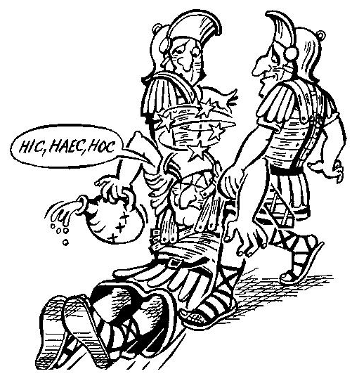

We also discussed the difference between the adjectives pulcher (beautiful, handsome, also good, fine in a moral sense), bellus (pretty, charming, agreeable) and fōrmōsus (from fōrma, normally used just for physical beauty). Bellus , from which bellāria (-ōrum n, pl, dessert) derives, has, of course, survived as the primary word for beautiful in the Romance languages, whilst fōrmōsa survives in the name given by the Portuguese to Taiwan.

Whilst waiting for latecomers to arrive, there had earlier been discussion of whether perveniō or adveniō was the best translation for the verb in that context. The dictionary entries did not point to any difference between them so both can probably safely be used as translations of `arrive’. The literal translation digitum extrahere was proposed for `get my finger out’, though it was unclear whether Romans used the phrase figuratively.

We also briefly noted that, in contrast to English and other languages where it is polite to put the pronoun `I’ last when it is joined with another noun, the Latin rule was to place it first. The 16th century English statesman Cardinal Wolsey, who famously started a sentence with the words Ego et rex meus was, as a Latin textbook aptly put it, `being a bad courtier but a good grammarian.’ King Henry VIII was certainly not a man to enjoy being in second place and, although the incident is fictional, the sequence in the film A Man for All Seasons where he’s annoyed by Margaret More speaking Latin better than he himself does is quite true to his character: http://www.youtube.com/watch?feature=player_embedded&v=Bwfao03B2h0 (transcript of the Latin is available on http://linguae.weebly.com/latin--greek.html (search on the page for `Margaret’)
It was agreed that, for modern Latinists, it was permissible to jettison the correct classical Latin word order and put ego at the end of the phrase.

There was a brief discussion of the Cambridge IGCSE Latin examination, which three of John’s students will be taking in the summer. John is currently producing notes on the verse set text, Aeneid Book II, lines 250-317 and 588-725 and will send the latest version to anybody interested. A difficulty is providing sufficient coverage of stylistic questions, on which candidates are also required to comment. Stefan mentioned hyperbaton as the technical term for separating words which naturally go together (as is is often done with noun-adjective phrases in Latin poetry.) The Latin for figure of speech is figūra (= Greek schēma) or tropus (-ī m). John thought that the latter was used particularly for the use of an individual word in a figurative sense but in fact it refers to figures of speech of all kinds (Aelius Donatus, a 4th century grammarian and commentator on Virgil, wrote a brief catalogue Dē Tropīs (text at http://www.intratext.com/IXT/LAT0365/_P1.HTM ) which includes hyperbaton, metaphor etc.)

We also identified differences in the German and British methods of testing Latin at the first public examination. In the British systems, no reference books are allowed into the examination room and students are required primarily to answer comprehension questions and/or translate:

(i) simplified passages which they have not seen before

(ii) extracts from prescribed texts which they have previously studied intensively.

Questions on the style of the prescribed texts are also included though counting for a relatively small proportion of the marks. For details of the currently prescribed IGCSE texts see http://linguae.weebly.com/igcse-latin.html

Under the German system, in contrast, candidates are required during the examination to translate longer pieces of original Latin with the help of a dictionary but without any other reference books – a procedure which is, in fact, a better test of the skills that a Latin student should be aiming to acquire.

John realized that in the last meeting he’d confused the phrase `emerald isle’ (referring to Ireland) and `scepter’d isle’ (used by Shakespeare – in defiance of geography! – to describe England in Richard II). Pat had suggested īnsula gemmāta for the first phrase so we could probably press into service īnsula sceptrāta (coining a verb sceptrō from the noun sceptrum). The etymology of `emerald’ itself is particularly interesting. The Latin smaragdus (from which the English word derives via medieval French) is a loan-word from Greek (smaragdos), which in turn derives from the Semitic root baraq (`shine’). See also http://www.etymonline.com/index.php?allowed_in_frame=0&search=emerald&searchmode=none , which puts the first use of `Emerald Isle’ for Ireland in 1795.

Although we were not eating any of them, the question of translations for pig’s intestines (intestīna porcīna) and chicken’s testicles (testiculī gallinaceī) came up. Other English terms for intestines were considered. Both entrails and bowels are ultimately derived from Latin: respectively a supposed Vulgar Latin term interālia (interior parts) and botulus (sausage). Bowels was the term used in the sentencing of people convicted of high treason – the medieval formula (apparently left on the statute book until 1870) was: “That you be drawn on a hurdle to the place of execution where you shall be hanged by the neck and being alive cut down, your privy members shall be cut off and your bowels taken out and burned before you, your head severed from your body and your body divided into four quarters to be disposed of at the King’s pleasure.” Further details at http://www.capitalpunishmentuk.org/hdq.html

Kristina had proposed for translation a quotation from David Bohm & David Peat, Science Order, and Creativity, p.247:
"What is essential here is the presence of the spirit of dialogue, which is in short, the ability to hold many points of view in suspension, along with a primary interest in the creation of common meaning."

Before the meeting John had suggested:

In hīs rēbus necessārius est spīritus dialogī, per quem, ut breviter dīcam, possumus multis sententiīs dīversīs pro tempore relictīs habēre creātiōnem conceptuum commūnium maximī esse momentī.

Consulting the dictionary revealed that `temporarily’ should be in tempus (or ad tempus) rather than pro tempore and Stefan made alterations both to get closer to the original English and to make the idiom more classical:

In hīs rēbus necessārius est spīritus dialogī, quī, ut breviter dīcam, est facultās multās sententiās dīversās in tempus relinquendī cum maximō stūdiō conceptūs commūnis creandī.

We pondered various renderings of the Cantonese gwái máah (鬼馬), which John thought meant someone who does things on the sly and therefore, as Tan pointed out, is close to the English idiom `a dark horse.’ Translating literally we might have Latin equivalents equus umbrōsus or equus spectrālis , while `dark horse’ could be equus opācus. However, investigations after the meeting revealed that the Cantonese phrase, used verbally or adjectivally rather than as a noun, in fact means something like being a joker (so probably joculāns).

Finally, five links which may be of interest:

I. Some of the `Mayan Apocalypse’ video used in Macau last month can now be seen on YouTube (http://www.youtube.com/watch?v=uEgeSVbPCK4 The Latin is not very clear on the video and only the first couple of lines of the original recording made in Hong Kong (see last month’s minutes for full version) seems to have been used:

Mediā nocte, orbem terrārum morte, metū et excidiō in potestātem meam redigam! Sōl tempestāte devorābitur. Magnetismus terrestris revertētur. Tellus in tenebrās clādēsque incidet.
(When midnight comes, I will take over the world with Death, Fear and Destruction. The Sun will be devoured by storm. The terrestrial magnetism will reverse. The Earth will fall into darkness and disaster.)
Probably invertētur would have been a better choice of word than revertētur to translate `reverse’, since the latter Latin word would most naturally be interpreted as a deponent verb meaning `will return.’ However, the other noise in the square probably ensured that any Latinists in the crowd did not notice the mistake!

II http://hiberna-cr.wikidot.com/downloads
Walter Ripman's `Classified Vocabulary' and Carl Meissner's `Latin Phrase Book', both topically organised and digitalised here as freely downloadable and searchable PDF files, are valuable resources for anyone wishing to read or write Latin. Also available from this page is Diederich's list of the commonest 1500 Latin words, which account for over 80% of words occurring in a typical classical or medieval text. Carolus Raeticus's site contains in addition links to a number of simple Latin readers also available free on the Internet.

III. Until the book goes on retail sale for about US$5,, the final version of Geoffrey Steadman's user-friendly new edition of Ritchie's FABULAE FACILES, meant as a bridge between a basic Latin course and the reading of authentic classical texts, can still be downloaded freely from his site (http://geoffreysteadman.com/ritchies-fabulae-faciles/) as a pdf file (the download to Hong Kong may be slow and it is better to save the file to your hard disk rather than opening immediately; if you still have no luck, ask John to email a copy). The text itself and vocabulary with Steadman's own commentary are presented on facing pages. The words included in the vocabulary for each page are those which occur less than 15 times in the book. Commoner words are grouped together in an alphabetically arranged list which the learner is encouraged to master before tackling the stories. This is an excellent resource both for learners and for those reactivating rusty Latin reading skills. Details of how this can be used in conjunction with my own bilingual versions of some of the Perseus and Hercules stories are at http://linguae.weebly.com/latin--greek.html (use the in-page search function to find `Steadman'). If anyone is unable to download Steadman’s text,

IV http://bestlatin.blogspot.hk/2013/01/special-edition-my-review-of-hobbitus_9.html
Laura Gibbs, a well-known on-line Latin teacher and folklorist, provides an appreciative review (in English!) of Mark Walker’s recent translation of The Hobbit.

V http://linguae.weebly.com/hyacinthus.html
The original Latin libretto of Mozart’s first opera, Apollo et Hyacinthus, composed when he was 11. There is an embedded complete recording on YouTube of a 1990 performance, though unfortunately with Japanese subtitles obscuring part of the screen!
QUESTIONS ARISING FROM THE 27TH MEETING (22/2/13)

Copies of the Papal resignation speech and of the new stretch of dialogue on the Circulus webpage were distributed. Despite one slip-up in noun-participle agreement, this is actually a very good piece of Latin, which is easy to read while at the same time providing examples of almost all the main constructions an intermediate Latin student is supposed to know.

Pat had been enduring the never-ending rain in the `sceptred isle’ (īnsula sceptrāta) but had also been on a trip to Ethiopia, whose very conservative Church (ecclēsia cōnservātīvissima) still insisted on using religious texts copied by hand rather than printed, and elderly priests laboured long years to produce these. Ethiopia is also famous for the 17th century Fort Gondar. Pat himself wanted to use the medieval word fortalicia but the classical term would have been castellum, commoner than castrum, from which it derives. The plural castra (very common in Caesar and other authors) means `camp’ since this is made up of a number of separate tents or barrack blocks for the soldiers. We also discussed the translation for guide, suggesting dux or ductor; a check with Lewis and Short confirms this, and Livy also uses ducentēs (the ones leading the way) when mentioning how Hannibal’s guides sometimes deliberately led him astray in the Alps.

Also up for translation was root canal treatment (curātiō canālium rādīcālium?), a prospect currently facing John. The word treatment itself is etymologically connected with tractātiō but that word means handling or treatment of a situation or a person rather than of a medical problem. We then also looked at the word argentāria (bank), which was not a vast office on modern lines but a shop or just a stall set out in the market-place, with the banker (argentārius) keeping his records at home, as in the case of Lucius Caecilius Iucundus of Pompei, immortalized by the fictional adventures of his household in book 1 of the Cambridge Latin Course. Both these words are in origin forms of the adjective argentārius, -a, -um (pertaining to money), with argentāria short for taberna argentāria

John mentioned an 1850 essay he was reading that was written by a Nepali soldier who ended up in London working as a pavement sweeper in front of St. Paul’s. That year the prime minister of Nepal(see the illustration), who was later to make himself maharaja, visited London as head of a diplomatic mission. As the first ruler of a South Asian state to make such a trip, he made a sensational impact and one day as he passed by in his carriage, the sweeper revealed his nationality and was at once taken on as an additional interpreter-cum-assistant. More on this at http://linguae.weebly.com/nepali.html (scroll down to `Moti Lal Singh – the first Nepali in London?’)

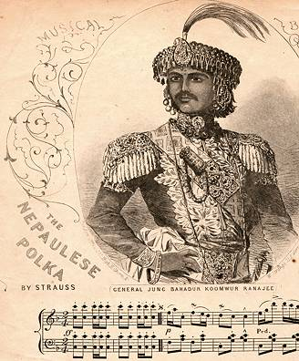
We also discussed the `Chinese rites’ controversy and a recent lecture at CUHK by Professor Nicolas Standaert about the letters from individual Chinese which the Jesuits had gathered together and forwarded to Rome in support of their argument that three fundamental features of Chinese `civic religion’ – homage to Confucius, honouring ancestors and the emperor’s annual sacrifice to the Lord of heaven - were not incompatible with Chrisitanity (the subject of the lecturer’s 2012 book Chinese Voices in the Rites Controversy – see http://www.douban.com/group/topic/34058037/ ) The Jesuits had themselves also presented an account of their position to the Chinese emperor who approved it as consistent with Chinese tradition. The account, with material in Manchu, Chinese and Latin, was published in 1701 as Brevis Relatio. Although the Pope eventually ruled against the Jesuits – and even declared that further discussion of the issue would amount to heresy – the material produced is preserved in the Jesuit archives in Rome and also in the publications of one of the Jesuit negotiators who later based himself in Prague where he continued his study of Chinese philosophy.

Pat mentioned that James II in the 17th century got the Pope to lend him the services of a Chinese who catalogued (in Latin) the Chinese books which the Bodleian library at Oxford had already begum to collect even before there was anyone available to study them.

Finally, on the question of national identity/-ies in Britain, John recommended Linda Colley’s Britons: Forging the Nation (see http://www.amazon.com/Britons-Forging-Nation-1707-1837-Revised/dp/0300152809 )

QUESTIONS ARISING FROM THE 28th MEETING – 15/3/13

We hit upon Potesne cibum attinēre? for Can you reach the food? And Tibi aliquid huius/illius dem for Can I help you to this/that? An alternative for the latter might be Velisne me tibi aliquid huius/illius dare? (Would you like me to give you some of this/that?)

We again discussed briefly some of the main courses available for those beginning study of the language. Unless one is making a bulk purchase, the cheapest way of obtaing the books in Hong kong is to use Bookdepository.com:

A. Cambridge Latin Course (Books 1-5):
This series has almost cornered the market in the UK, where it is used by over 90% of the schools teaching the language, and is also used in many other countries. This is a reading based course, with grammar presented but kept in a subsidiary position, There are some exercises requiring the insertion of correctly inserted forms (from alternatives given or with the help of grammatical tables at the back of the book) but no English-Latin translation, although Latin comprehension questions for most of the stories are available at http://linguae.weebly.com/quaestiones-cantabrigienses.html (the book’s own questions are all in English):

QUAESTIŌNĒS AD CAPITULUM 14 CŪRSŪS CANTABRIGIĒNSIS PERTINENTĒS

Rūfilla
1. cūr volēbat Rufilla in urbe Londiniō manēre?
2. quid volēbat Rufilla habēre ubi in urbe habitābat?
3. habentne Salvius et Rūfilla vīllam prope urbem?
4. quis hanc vīllam elēgit?
5. cūr nunc nōn commodum est Rūfillae in vīllā rūstica manēre?
6. cūr Salvius erat attonitus, ubi Rūfillā dīxit `sōla sum’
7. habetne Rūfilla coquum Graecum?
8. quid fēcit Rūfilla in fīne? (in fīne, at the end)

The strengths of the Cambridge course are its engaging story line, the presentation of new language material in comic strip form and its free-access website (http://www.cambridgescp.com/Lpage.php?p=clc^top^home) which includes texts of all the stories with hyper-linked glosses. There is also a range of suplementary audiovisual material which has to be purchased, though there are sample recordings of a couple of the stories freely available at the start of Book 2 (Stage 13) and audio of individual words in the site’s dictionaries for Books 1 and 2.

B. Nicholas Oulton, So you Really Want to Learn Latin (Books 1-3)
This is a complete contrast to Cambridge as it takes a highly traditional approach, concentrating on the sytemeatic pesentation of grammatical rules, manipulation of forms and translation from and into Latin. It differs from older books, however, in combining humour with grammatical rigour – there is a constant stream of jokes in the text, plus a large number of cartoons (see the one included in the minutes for the 26th Circulus meeting above). It also includes a tongue-in-cheek summary of the main outlines of Roman history down to the foundation of the Principate. John uses this book with a couple of students who are trying to learn the basics of the language rapidly and it might also be suitable for someone wanting a grammar refresher course. For those with an analytical bent, using this course and suplementing it with some of the Cambridge stories for extra reading practicce might be a good approach.

C Latin via Ovid (preview available on Google Books at http://books.google.com.hk/books?id=fORWW12AoTAC&printsec=frontcover&dq=Latin+via+Ovid/#v=onepage&q=Latin%20via%20Ovid%2F&f=false
This book, which is used in John’s adult beginner’s classes at the Dante Alighieri Society, presents all the basic structures of Latin plus an extensive vocabulary in a single volume and was designed for use on undergraduate courses It combines a traditional approach to grammar with retellings of the stories from Ovid’s Metamporphoses, starting with very simple paraphrases and increasing in complexity till the poet’s own text is being read at the end. Although the grammar is presented rather less systematically than in Wheelock (the best-known traditional grammar-focussed course in the USA) or in Oulton, and the use of phrases from poetry makes the Latin less straightforward than the made-up soties in Cambridge the interest of the myths themselves and the comprehensive coverage of the language it make it a better choice for many learners. Powerpoint presentations to accompany many of the stories are available at http://linguae.weebly.com/latin--greek.html (scroll down to (or search for) `Teaching aids for Latin via Ovid) with quotes from the book’s texts plus illustrations taken from all periods of western art, for which Greek mythology has been a constant source of inspiration.

Because our new member, Zhang Wei, will shortly be going to Vilnius, and Tanya and Kristina are from Latvian and Lithuanian families respectively, some time was spent discussing the Baltic states and their languages. Pat believed that the Estonian language (related to Finnish, in contrast to Latvian and Lithuanian which belong to the Baltic branch of Indo-European) had 18 cases, one of which was termed `optative’. A Google check suggests that there are in fact `only’’ 14: nominative, genitive, partitive, illativem inessive, elative, allative, adessive, ablative, translative, terminative, essive, abessive, comitative (see http://en.wikipedia.org/wiki/Estonian_grammar for details). It’s convceivable that some linguist might have used `optative’ as an alternative label for one of these, but that term is normally reserved for a verb mood (contrasting with the indicative, imperative and subjunctive moods). The optative’s functions were subsumed by the subjunctive in Latin but it survived as an indepenent category in ancient Greek and in Sankrit. The Latin present subjunctive of the verb esse (sim, sis, sit etc.iscognate with the optative of the corresponding Sanskrit verb (syām, syās, syāt etc.)

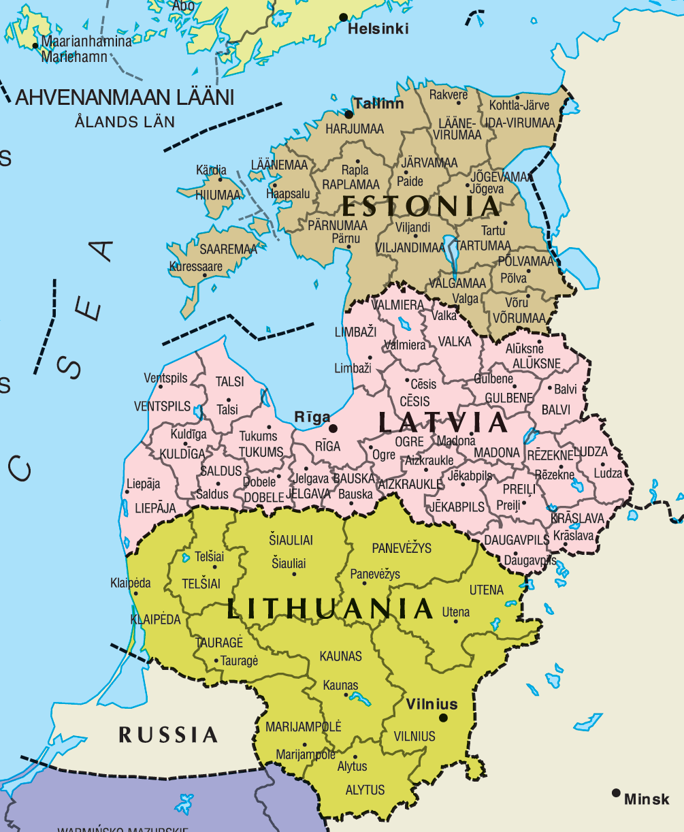

Mention was also made of the almost-extinct Livonian language, which is related to Estonian but spoken in Latvia by a handful of native speakers remaiing. (probalby now less than10).

Lithuania was one of the last regions of Europe to abandon paganism and accept Christianity and it was also for a brief period the centre of an empire including extensives areas of Russia, Poland and the Ukraine. A recent detailed treatment of this is S.C. Rowell Lithuania Ascending: A Pagan Empire within East-Central Europe, 1295-1345. http://www.amazon.com/Lithuania-Ascending-East-Central-1295-1345-Cambridge/dp/052145011X/
An older and briefer treatment is a book by the Indian linguist Suniti Kumar Chatterji, best known for
his pioneering work on the history of his native Bengali language. Chatterji was particularly interested in the parallels between Baltic folk poetry and early Indian literature, both of which reflect an ancient Indo-Euopean inheritance. Kristina has a copy of his Balts and Aryans in their Indo-European Background (Simla: Indian Institute of Advanced Study, 1968), which is a good introduction to the topic, though, in the light of recent political changes, his claim that the Baltic States were happy with their incorporation into the Soviet Union reads rather strangely.

We also touched on relation between the Baltic peoples and the Germans, whose eastwards expansion was a trend that persisted for many centuries. Pat believed that the merchants of the Hanseatic Leaague, a lose association of German-speaking merchant communities along the Baltic coast, were required to remain unmarried manly to avoid intermarriage with the non-Germanic peoples around them. However, a brief Internet search after the meeting did not yield any mention of this.
QUESTIONS ARISING FROM MEETING 19/4/13

We welcomed a new member, Tomo Sato, who is from Japan, runs an IT firm (societās technicae infōrmatīvae addicta?) and is also a long-term student of Italian. The word for Japan is Iaponia, -ae f with derived adjectives Iaponicus, -a, -um and Iaponēnsis, -e. On analogy with Sīnicus/Sīnēnsis, it’s probably best to use Iaponēnsis as the adjective of nationality and Iaponicus as an adjective for language, institutions etc. There is a similar distinction for a number of countries, so, for example, a native of Britain is referred to as Britannus/Britanna but Claudius’s son, named to commemorate his father’s annexation of the island, was Britannicus (= with a connection to Britain but not a native). Recommended usage for various countries is shown in the table:

COUNTRY NOUN/ADJECTIVE GENERAL ADJECTIVE
FOR NATIVE PERSON
Sīna (OR Sīnae) Sīnēnsis Sīnēnsis/Sīnicus
Britannia Britannus/a Britannicus
Hibernia Hibernus/a Hibernicus
Italia Italus/a Italicus
Gallia Gallus/a Gallicus
Francia/Francogallia Francogallus/a Francogallicus
Germānia Germānus/a Germānicus
Hispānia Hispānus/a Hispānicus/Hispāniēnsis
Graecia Graecus/a* Graecus
Iaponia Iaponēnsis Iaponēnsis/Iaponicus
Corea Coreānus/a Coreānus
Civitātes Unītae Americānae Americānus/a Americānus
Africa Austrālis Austroafricānus/a Austroafricānus
Austrālia Austrāliānus Austrāliānus
Lithuānia Lithuāniēnsis Lithuāniēnsis
Latvia Latviēnsis Latviēnsis

The plural form Sīnae is more often used today but it is perhaps more convenient (and politically more correct!) to use the singular. The spelling China is also occasionally found in early modern texts (e.g. in the title of Kircher’s 1664 Latin publication China Illustrata) but not used nowadays.

We looked at the old question of the Latin equivalent of `You’re welcome’ or `Don’t mention it’ in a response to being thanked. Although there is no definite proof that it was actually in use, something like dē nihilō was probably the origin of phrases like de nada in Spanish. Another possibility is libenter (literally gladly), which John often uses but which some people believe normally meant rather `No thanks.’ For that function there was certainly benignē (`that’s kind of you but…) (see Lewis & Short, and Traupmann’s Conversational Latin p.25.) but with the complication that, rather like French merci, it could also be used when accepting an offer. It’ probably best in conversation today, then, to stick to benignē for polite refusals and use either libenter or dē nihilō when someone thanks you.

Also briefly discussed was the question Benē tē habēs? (Are you well?). Another formula is Quid agis? (literally What are you doing? but usually meaning How are you doing?/How are things?). To either question an appropriate reply would be Bene mē habeō (I’m fine). Other phrases mentioned were Tōtum ad tē (All over to you), Prōsit (cheers!) and occupātus, -a, -um busy.

We briefly considered the Latin for different cooking methods. Effervescō (-ere, -fervī) and ferveō (fervēre, ferbuī) can be used for boil in the intransitive sense whilst fervefaciō is transitive but perhaps not sufficiently precise as it basically just means `make very hot’. The equally imprecise coquō (cook) and its compounds were also used in the same sense. However the late Latin ēlixō (-āre, -āvī, -ātum) definitely meant to boil thoroughly and the related adjective ēlixus, -a, -um meant boiled, so pisci ēlixus would be boiled fish. For steam (transitive) probably vapōre coquō would do, so steamed fish would be piscis vapōre coctus. For roast there is the well-attested assō (-āre, -āvī, assum) so roast meat would be carō assa. Different types of meat were referred to by an adjective from the name of the animal with carō either added or (more usually) left unexpressed. So the roast goose we ate was anserīna assa.

Alex is producing a series of short animated films demonstrating the use of the conversational words and phrases from the start of VOCABULA ET IUNCTURAE and using the Xtranormal platform which automatically syncs the lip movements of the characters you select with your recorded conversation. There were one or two bugs caused by errors John had not corrected on the website, including leniter (gently) instead of lentē (slowly) and Anglīcē for the correct form Anglicē (making the ī long also means that, as the penultimate vowel, it is automatically stressed so the error is very apparent in a recording.) John also thought he had made a mistake by writing Honcongī īnsulā but later realized that it IS possible to have a locative followed by an ablative in apposition to it without any preposition. However, the alternative phrase structure – preposition plus ablative plus locative (in īnsulā Honcongō) is more usual and both website and video now have this. The videos so far accessible are at:
http://www.youtube.com/watch?v=YUZL3vXPJeQ
http://www.youtube.com/watch?v=RDq1Np_MLf0
http://www.youtube.com/watch?v=MkM3f_OTg9k
http://www.youtube.com/watch?v=AwN8V0j8nWc

The locative (a fully-fledged case in proto-Indo-European and in Sanskrit but retaining only some fossilized uses in Latin) has the same ending as the Dative/Ablative in the plural (e.g. Athēnīs, Novemdracōnibus, in Athens, in Kowloon) but in the singular is identical with the Dative/Genitive in the 1st declension (Rōmae, in Rome), with the Genitive in the 2nd. (Londīniī/ Londīnī) and normally with the ablative in the 3rd (Carthāgine). The locative is used without any preposition with names of cities and also small islands (because a small island would have only one city, the largest island in this category in the Graeco-Roman world being Rhodes with an area of 540 square miles.). It is also found in the forms rūrī (<rūs, rūris n), hūmī (<humus, -ī m), domī (<domus, -ī f). Other nouns use the ablative with a preposition and the difficulty arises when both sorts of noun are used in tandem. In such cases the ordinary noun must take a proposition if it precedes the place-name, and the place-name itself will then also be put in the ablative (e.g. in urbe Rōmā ). If the place-name comes first, then this is in the locative and the ordinary noun in the ablative may be used with or without a preposition, Rōmae, urbe praeclārā OR Rōmae, in urbe praeclāra, in Rome, a famous city Alex suggested that perhaps the locative could be used for both nouns where the ordinary noun was regarded as part of a name (as in Portus Itius (the port Julius Caesar sailed from to Britain) but it seems from Caesar’s usage that portus would still be treated as an ordinary noun in this case.

There is an added difficulty in that the name of a small island could be used in the ablative with in if the reference was to the place as an extent of territory rather than as city/political unit. We think of Hong Kong in both ways, so there’s a case for sometimes writing in Honcongō but John fixed on the locative (Honcongi) early on and has stuck with that.

There was brief discussion of Roman writing methods, which included writing on papyrus, parchment or thin pieces of wood with ink and pen or with a stylus on a wax tablet. The last-mentioned method was the commonest for everyday writing, with the wax contained in a recessed, wooden tray, two of which were generally joined together with string and could be folded together without disturbing the wax ((see http://es.scribd.com/doc/2342118/Roman-Writing). The writing could, however, be erased by simply using the blunt ends of the stylus to smooth the wax. If the writer pressed too hard, the stylus would leave an impression on the soft wood below and this may still be readable today, long after the wax itself vanished. For writing with ink, a reed pen (calamus) was probably most common instrument but quill pens were also used and penna (feather) is used in this sense in late Latin so this term can reasonably be used for a modern pen also.

The Vindolanda archive, a collection of letters written by and to soldiers and their wives at a fort just south of Hadrian’s wall in Northumberland, includes some writing tablets that would have been used with wax but mostly consists of thin pieces of wood about the size of a modern postcard. The most famous of these, a birthday party invitation sent to the garrison commander by the wife of another senior officer is shown below, with an artist’s impression of how the fort itself might have looked. These illustrations are taken from the presentation BRITANNIA which contains a transcript and translation of the invitation and can be downloaded from http://linguae.weebly.com/latin--greek.html The complete archive can be consulted on line at: http://vindolanda.csad.ox.ac.uk/ .
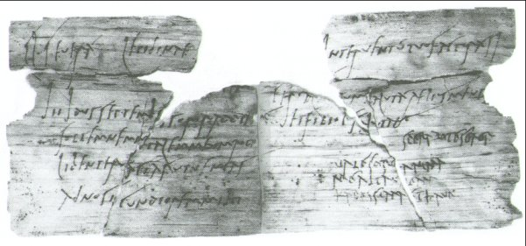
A birthday invitation

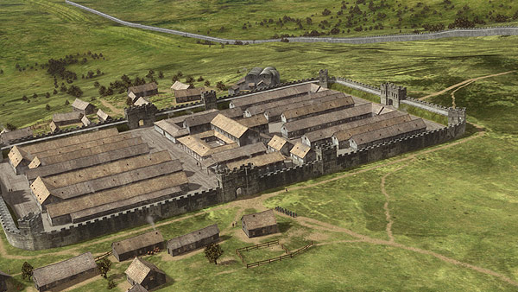

Vindolanda fort, c.100 A.D.

Pat also mentioned that the extensive use of Latin for government records in Britain continued till the 15th century. Records of births and death were still kept in Latin until 1733.

Other words and phrases that cropped up were influentia aviāria for bird flu, capsicum (which we have discussed before) for chilli and the Latin for interesting. There does not seem to be a Latin adjective corresponding exactly to English interesting (the Latin from which that word derived meant `be of concern to’) and it’s usual to use a verbal phrase like mē tenet (`it holds me’) to convey the idea.etc. Finally, John pointed out that, though we’ve long been using Honcongum, there is a case for Honconum as ng in Latin is always a double consonant (as in English finger). Custom and practice will prevail, however, so we won’t be changing our official name.

QUESTIONS ARISING FROM 30th MEETING 10/5/13

Glasses were raised to Alex on his birthday but in absentia as he was unwell today (he is now fully recovered). Tanya, with some assistance from other members, speculated (not altogether inaccurately!) on the cause of his condition:

In vigiliā diēī nātālis

Alexander ad caupōnam nōn vēnit. Cōnsodālēs inter sē suspicābantur, `Fortasse Alexander aeger est quod vigiliam diēī nātālis in tabernā celebrāns ēbrius factus est.’ Crēdimus corpus Alexandrī nōn sānum, sed mentem sānam esse.

The Latin adjective sānus simply means `healthy’ and is not restricted to mental health like its English derivative. The noun vigilia, which has the technical meaning of a fouth part of the night, could also mean `watchfulness’ or `vigil’ and in the Middle Ages cam principally to mean the vigil (night preceding) a feast day. The Latin for drunk is ēbrius (from which inebriated derives) means drunk. The constuction after crēdimus is `accusative and infinitive’, literally `we believe the body not [to be] healthy...’

We looked at Thomas Crean’s translation of a whimsical newspapr editorial on the waning in Britain of the tradition of families sitting around a table to eat together:

IN EDENDO MORES APUD BRITANNOS

Familiae quibus deest mensa in dies frequentius inveniuntur. Ex quinis enim hominibus singuli cibum sumunt adsidentes mensae culinari semel tantum vel bis in hebdomada. Triclinia autem si quaeris, scito magnam partem civium numquam plane recumbere. Fatemur nos animo offendi quod supellectiles hae solidissimae, quas credebamus perpetuas, ita concidunt et quasi evanescunt. Semotis enim mensis, nulli boni in edendo mores ; ut, pari ratione, petasis obsoletis capita non iam aperiuntur dum transit currus exsequialis sed manibus potius plauditur {id quod recens in Margaritae Thatcher funere accidit}.

Gravius vero est mensas aboleri quam cultros piscatorios, sine quibus pisces humane êsse licet. Immo gravius quam pocillos ovis elixatis aptos desuesci, quo tamen deliciae pristinae periculum redduntur. Nam sine mensa e familiis sermone congregatis turba incondita exstamus qui Genghis illius Khan vagorum instar in commeando vescimur.

Original English:
The proportion of households with no table is rising. Already one person in five eats at the kitchen table only once or twice a week. As for a dining-room table, a great slice of the populace never visits it from one year’s end to the other. This sudden collapse, or vanishing into thin air, of the sturdy table comes as a shock. We had taken it for granted. And no table means no table manners. In that respect it follows the hat, which, being absent, can no longer be removed. Hence applause, instead, at funeral cortèges.
The disappearance of the table is not at all like the disappearance of fish-knives. Fish can be eaten in a civilised way without fish-knives. It is even worse than losing egg-cups, without which boiled eggs are more of a hazard than a treat. Yes, the loss of the table turns us from families with table-talk to a random rabble, eating, like the hordes of Genghis Khan, on the hoof.

Pat objected to the use of plānē recumbere for people sitting at the dining room able, since the phrase properly means lie down flat, as the Romans, of course, did for formal meals. John argued that the expression could be justified since in this case lying flat and sitting were cultural equivalents. However, if we want to be strictly accurate, the phrase needs to be something like numquam ibi (i.e in tricliniis) mensae adsīdēre or (translating visit more literally) nunquam illūc (i.e in triclinia) ingredī. Pat also pointed out the connection between semel (once) and simul (at the same time)

We also discussed Raimundus de Agiles’s eye witness description (in his Historia Francorum Qui Ceperunt Ierusalem ) of the massacre that followed the capture of Jerusalem by the Crusaders in 1099. The translation distributed at the meeting was from C. Krey, The First Crusade: The Accounts of Eyewitnesses and Participants, (Princeton: 1921), p257-62. The full extract is available on the `Medieval Sourcebook’ site (http://www.fordham.edu/halsall/source/raymond-cde.asp) and the paragraph on the massacre at http://linguae.weebly.com/nomen-a-solemnibus.html, as an appendix to the text of a song commemorating the event.

"Alii namque illorum, quod levius erat, obtruncabantur capitibus, alii autem sagittati, de turribus saltare cogebantur; alii vero diutissime torti, et ignibus adusti flammeriebantur. Videbantur per vicos et plateas civitatis aggeres capitum, et manuum atque pedum. Per cadavera vero publice, hominum et equitum discursus erat. Sed parva et pauca ista quae diximus. Sed ad Templum Salomonis veniamus, ubi suos ritus atque solemnitates cantare solebant. Sed quid ibi factum est? Si verum dicimus, fidem excedimus.Sed tantum hoc dixisse sufficiat quod in templo et in porticu Salomonis, equitabatur in sanguine usque ad genua, et usque ad frenos equorum iusto miroque Dei iudicio, ut locus idem eorum sanguinem exciperet, quorum blasphemias in Deum tam longo tempore pertulerat. Repleta itaque cadaveribus et sanguine civitate, confugerunt aliquanti ad turrem David, et poposcerunt a comite Raimundo securitatis dextram, et reddiderunt ei arcem."
(Raimundus De Agiles, Historia Francorum Qui Ceperunt Ierusalem , Caput XXXVIII)
“ Some of our men (and this was more merciful) cut off the heads of their enemies; others shot them with arrows, so that they fell from the towers; others tortured them longer by casting them into the flames. Piles of heads, hands and feet were to be seen in the streets of the city. It was necessary to pick one's way over the bodies of men and horses. But these were small matters compared to what happened at the Temple of Solomon, a place where religious services are normally chanted ... in the temple and the porch of Solomon, men rode in blood up to their knees and bridle reins. Indeed it was a just and splendid judgment of God that this place should be filled with the blood of unbelievers since it had suffered so long from their blasphemies. So with the city filled with bodies and blood, some fled to the Tower of David, asked Count Raimond for a guarantee of their safety and then surrendered the citadel to him.' ”

John argued that Pope Benedict XVI, who caused controversy with a speech referring to Muslims’ use of violence to spread their religion, could have avoided trouble by also citing this episode as well and acknowledging that brutal extremism had also been a problem in Christianity. Religious violence was also prominent in the Old Testament, especially in the account of how God punished Saul for not killing all of the Amalec tribe. Pat, however, argued that, though in the Christian scriptures god had ordered violent action on specific occasions, violence was more central to Muslim belief, since Mohammed himself had been a military leader; he also cited a sura from the Koran forbidding the faithful from having Christian friends. This led on to a brief discussion of Zoroastrianism, the pre-Islamic religion of Iran. The highest-profile Zoroastrian community today are the Indian Parsis, but there are actually still some left in Iran itself. Although the Iranian census puts the current total at only 26,000 there are unofficial estimates varying between 1.5 and 3.5%.

There were several apparent problems with Krey’s translation of Raimundus’s text and these were discussed both during the meeting and in subsequent correspondence:

- Pat thought it unnecessary to turn the first sentence from the passive into the active voice with `our men’ introduced as subject and preferred instead "Some of them (and this was the more merciful) had their heads cut off; others were shot with arrows so that they fell from the towers ..."

- He also thought there might be something wrong with the phrase "Per cadavera vero publice" and
that the original text might have read viae publicae (vie publice in medieval orthography),
meaning `on the public (i.e. principal) streets’. However, to be grammatical, the phrase would
need to be in vis publicis and it is probably unnecessary to make such a drastic emendation as the
adverb publice could quite naturally be taken as meaning `in the public areas’
streets.’

- The verb solebant in "ubi suos ritus atque solemnitates cantare solebant" is in the past tense and
the reference is clearly to the Muslim rituals which were performed there before the city’s capture.
Pat suggested translating "where their rites and solemnities used to be chanted." But we could
keep the active voice as in the Latin and have instead “where they used to chant their rights and
solemnities”

- The word `unbelievers’ (line 8 of the translation) does not correspond to anything in the original
which simply refers to God’s judgment that `the same place should be filled with the blood of
those whose blasphemies it had suffered for so long

Pat did , though, approve the translation of itaque (line 9) with a simple “so" , pointing out that for medieval writers itaque, namque" and igitur were often used just to mark pauses. The same can be said of classical authors’ use of the conjunction autem.

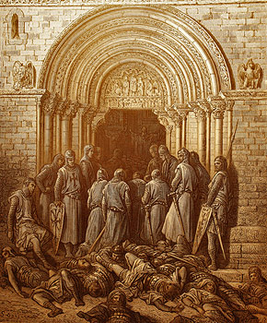

Cusaders entering the Church of the Holy Sepulchre over the bodies of slain Muslims.

We also looked at the first page of William Turpin’s edition of what is probably the earliest history of the First Crusade, the Gesta Francorum. This has been prepared for use in the free on-line translation course offered from 3 June by Dickinson College on Mondays from 8-10 p.m. EST (8-10 a.m. Hong kong time) and starting on 3 June. Further details of the course are available at https://sites.google.com/a/swarthmore.edu/medieval-latin-summer-2013-the-gesta-francorum/ The word gesta (from gerō, gerere, gessī, gestum) means `things done’ or `achievements’ and an equivalent phrase is rēs gestae (things done), which Augustus used for the summary of his own career (Rēs Gestae Dīvī Augustī) he ordered inscribed on the wall of a monument in Rome.

Gesta Francorum Liber I

1.1.1 Cum iam appropinquasset ille terminus quem dominus Iesus cotidie suis demonstrat fidelibus, specialiter in evangelio dicens: “Si quis vult post me venire, abneget semetipsum1 et tollat crucem suam et sequatur me,”2 facta est igitur3 motio valida per universas Galliarum regiones, ut si aliquis Deum studiose puroque corde et mente sequi desideraret, atque post ipsum crucem fideliter baiulare4 vellet, non pigritaretur5 Sancti Sepulchri viam celerius arripere. Apostolicus namque Romanae sedis6 ultra montanas partes quantocius7 profectus est cum suis archiepiscopis, episcopis, abbatibus, et presbiteris8, coepitque subtiliter9 sermocinari et predicare,10 dicens, ut11 si quis animam suam salvam facere vellet, non dubitaret humiliter viam incipere Domini, ac si denariorum12 ei deesset copia, divina ei satis daret misericordia.

1.1.2 Ait namque domnus13 apostolicus “Fratres, vos oportet multa pati pro nomine Christi, videlicet miserias, paupertates, nuditates, persecutiones, egestates, infirmitates, fames, sites14 et alia huiusmodi, sicuti Dominus ait suis discipulis: ‘Oportet vos pati multa pro nomine meo’15, et: ‘Nolite erubescere loqui ante facies hominum; ego vero dabo vobis os et eloquium’16, ac deinceps: ‘Persequetur vos larga retributio’17.” Cumque iam hic sermo paulatim per universas regiones ac Galliarum patrias18 coepisset crebrescere, Franci audientes talia protinus19 in dextra crucem suere20 scapula21, dicentes sese Christi unanimiter sequi vestigia, quibus de manu erant redempti tartarea.22 Iamiamque23 Galliae suis remotae
sunt domibus.24

1.2.1 Fecerunt denique25 Galli tres partes. Vna pars Francorum in Hungariae intravit regionem,scilicet26 Petrus Heremita,27 et dux Godefridus,28 et Balduinus frater eius,29 et Balduinus comes de
————————————
1 semetipsum (ML) = sese (CL).
2 Matthew 16:24.
3 “Therefore” is superfluous here, since cum ... appropinquasset is a cum clause of attendant circumstances (AG § 546); omit in translation.
4 bāiulo (1) “to carry a burden, to bear something heavy.”
5 pigritaretur (ML) = pigraret (CL) “be slow to.”
6 The apostolicus sacrae sedis was the Pope, i.e. Urban II, 1088-1099. The reference here is to the famous Council of Clermont, 18-28 November 1095.
7 quantōcius “as quickly as possible.”
8 “priests.”
9 here “elegantly.”
10 praedicō (1) “proclaim.”
11 ut + subj. can express indirect statement in ML.
12 dēnārius, iī, m. “denarius”; (ML) “penny.”
13 domnus (ML) = dominus (CL).
14 sitis, is, f. “thirst.”
15 Acts 9:16.
16 2 Timothy 1:8; Luke 21.15.
17 Matthew 5:12.
18 regiones and patriae are here “duchies” and “counties”; patria in the plural is only poetic in CL.
19 prōtinus, adv. “forthwith, immediately” (OLD 3).
20 suō, suere, suī, sūtum “sew”. Either a historical infinitive or dependent on coepisset.
21 “shoulders”; in CL scapulae, ārum f. pl. means “shoulder blades”; scapulum is ML.
22 Tartareus, a, um “of the underworld.”
23 iamiamque, adv. “at this time”; a strengthened form of iam.
24 Hill: “So they set out at once from their homes in the lands of the Franks.” Literally “So at once the Gallic lands were
removed from their homes.” [??] Lees has Iam iamque Galli e suis remoti sunt domibus, which seems much easier.
25 denique (ML) = itaque or nam (CL); in CL denique means “finally.”
26 “namely”; scīlicet in CL can mean “I mean” or “that is to say” (OLD 5).
27 Peter the Hermit.
28 Godfrey of Bouillon, duke of Lower Lorraine.
29 Baldwin, who will become Count of Edessa and then King of Jerusalem.
Pat explained that terminus means "season" (i.e. "Term" in the sense of a University term, which comes from "Terminus", or "Tide" as in "Eastertide"). The meaning is "At that season of the year when the Lord Jesus daily teaches his disciples". The background is that in November the readings at Mass (in the late eleventh century) concentrated on Jesus’s teaching of the disciples.

A quick check with the dictionary confirmed that semetipsum (oneself) is found in classical Latin, though most of the instances turned up by a later Google search of www.thelatinlibrary.com were indeed Medieval.

The text has the words Romanae sedis (of the Roman see) referring to the Church’s central government, whilst the editor’s note has sacrae sedis (of the Holy See). The normal medieval phrasing would have combined both: sacrae Romanae sedis. Pat also objected to the use of Apostolicus as a noun referring to the pope, arguing that the word was an adjective needing a noun such as vir (man) with it. However, the eye-witness account of the 1066 Battle of Hastings (Guillelmi Ducis Normannorum Gesta, Sidwell (ed.) Reading Medieval Latin, pg. 176).refers to the Norman invaders of England possessing vexillum quod apostolicus transmiserat (a flag which the pope had sent) and, generally speaking, almost any Latin adjective can be also be used as a independent noun. There is no doubt, though, that namque (literally for) in the middle of the Gesta’s phrase is just a `pause word’ with very little meaning.

In line 8, although denariorum literally means "of pennies", the plural is usually best translated just as money. Thus: "If anyone is short of money", or, more exactly, "If stores of money are lacking to anyone."

The classical Latin meaning of sermocinari is to hold a conversation or discuss but Pat pointed out the medieval one was to give a sermon and he also preferred to preach for predicare rather than the editor’s recommendation of to proclaim. Ut in dicens ut means "that", medieval Latin preferring a construction for reported speech similar to the modern English or French one in place of the classical accusative and infinitive. Finally, Pat also doubted whether regiones ac Galliarum patrias could have so exact a meaning as "duchies and counties" and preferred "in every corner of France".

There was finally a brief discussion on the Tai language family (Thai itself and associated dialects), which some people think my have been dominant in our own part of China before Chinese speakers moved down from the Yellow River. Pat explained that Tai-speakers who were living outside Thailand (in Yunnan and in other parts of South-East Asia) and had not become Buddhist were referred to by the Thais proper as `wild Thai’. These groups, whose myths claim a common place of origin at Sip Song Banna in Yunnan and who are divided into clans designated by different colours, believe that they are destined to re-assert their original sovereignty and that this has resulted in periodic uprisings against non-Tai governments in Vietnam and elsewhere. There was also mention of Korean, which is definitely related to certain Siberian languages and possibly also to Japanese, with which it has many structural similarities.
QUESTIONS ARISING FROM 31st MEETING, 7/6/13

We looked at part of the preface to Julius Mohl’s 1834 edition of a Latin translation and discussion by Jesuit writers of the Y-Ching, this being one of the documents in a collection of Latin writing on China which John is preparing for classes at CUHK at the end of the month. Mohl, a German who spent much of his career in France, where he died in 1877, a few years after the end of the Franco-Prussian War, was an important figure in the development of Sinology in the West, though also heavily involved in research into other Asian languages. The full text of the book is at:
http://books.google.co.jp/books?id=ZKo-AAAAcAAJ&printsec=frontcover&dq=Y-king,+antiquissimus+Sinarum+liber+quem+ex+latina&hl=ja&sa=X&ei=XkCwUcDbA4uokgWt7oDwCg&ved=0CD8Q6AEwAg

The extract we used (with interlinear translation added after the meeting) is:

Julius Mohl (ed.), Y-king: Antiquissimus Sinarum Liber ex Latina interpretatione . Regis et aliorum ex Soc. Iesu. P.P. (Stuttgart & Tuningen 1834), Praefatio, p. v-vii.

Inter omnes constat libros Sinicorum, quos classicos vocant, primum et antiquissimum esse
among all it’s-agreed books of-the-Chinese which classics they-call first and oldest to-be
Y-king (易經, Yì Jīng) qui non minus per auctoritatem, qua apud Sinas fruitur, quam per
I-Ching (Book of Canges) which not less by authority which amongst Chinese it-enjoys than by
obscuritatis famam apud omnes innotuit. Fohi (伏羲 Fú Xī), secundum opinionem Sinarum,
for-obscurity reputation among all became-known Fohi according-to opinion of-Chinese
trigesimo ante Christum saeculo symbola invenit, quibus doctrinam de rerum natura et origine
in-thirtieth before Christ century symbols discovered by-which doctrine about of-things nature and origin
graphice delinearet. Omnia enim ex duorum principiorum, activi et inertis, affectione mutua
in-drawings he-might-outline all-things for out-of of -two principles active and inert by-effect mutual
nasci tradidit, principiumque activum per lineam integram, iners per lineam interruptam
to-come-about he-taught and –principle active through line whole inert through line interrupted
designavit, et res quae de eorum conflictu ortae sint varia duorum symbolorum compositione
he-designated and things that from their conflict arisen have by-various of-two symbols combination
expressit. Ita 64 figuras, unamquamque ex sex lineis, tum integris, tum interruptis
he-expressed thus 64 figures each of six lines both complete and interrupted
composuit. Ipsius interpretatio periit, sed symbola ad posteros transmissa rursus atque rursus
he-composed his-own interpretation perished but symbols to posterity handed-down again and again
novarum doctrinarum fundamentum fuerunt; sic ad principis Ouen-ouang (文王. Wen
of-new doctrines foundation were thus to of-prince Wen Huang
Huang) tempus pervenere, qui (duodecimo ante Christum seculo) res imperii restauraturus
time they-reached who in-twelfth before Christ century things of-empire going-to-restore
novam symbolis doctrinam adjecit, cuique brevem adscribens sententiam, quibus nova de
new to-symbols doctrine added to-each short adding sentence by-which new about
moribus et reipublicae adminitratione praecepta indicarentur.
customs and of-state administration precepts could-beindicated
Post ipsum filius Tcheou-kong (周公旦, Zhōu Gōng Dan) patris opus completurus cuique
after man-himself son Zhou Gong father’s work going-to-complete to-each
sententiae sex novas addidit, quibus singulas cujusque symboli lineas interpretatus est,
sentence six new-ones added by-which individual of-each symbol lines he-interpreted.
physica ac metaphysica moralibus et politicis admiscens. Post sescentos exinde annos hunc
physics and metaphysics with-ethics and politics mixing after six-hundred from-then years this
librum Confucius, res Sinicas in antiquum statum revocaturus, denuo suscepit, commentariis
book Confucius things Chinese into ancient status going-to-restore again took-up with-commentaries
et appendice instruxit, in quibus sensum symbolorum Fohi ac sententiarum Ouen-ouang et
and with-appendix furnished in which sense of-symbols of-Fohi and of-sentences of Wen Huang and
Tcheou-kong explicaret, et primum locum inter sex libros. quibus imperii doctrinam contineri
Zhou Gong he-could-explain and first place among six books in-which of-empire doctrine to-be-contained
voluit, ipsi attribuit. Ab eo tempore ad hunc usque diem summae Sinis reverentiae
he-wished to-itself assigned from that time to this (up-to) day subject-to-greatest for-Chinese reverence
fuit, et quaecunque nova apud ipsos orta est schola, novae libri Y-king interpretationi
has-been and whatever new amongst them arisen has school upon-new of-book I-Ching interpretation
doctrinam suam superstruere studuit. Sic metaphysica ac physica, morum doctrina et
doctrine own to-base has-been-keen thus metaphysics and physics on-ethics teaching and
astrologia, rei publicae administrandae regula et rerum privatarum divinationes aeque ex Fohi
astrology for-state being-administered regulation and of-things private predictions equally from Fohi’s
symbolis derivantur. Nec apud Sinas tantum libri fama et reverentia stetit; inter eos
symbols are-derived nor amongst Chinese alone of-book reputation and reverence has-existed among those
etiam, quos misit ecclesia Romana legatos, ut Sinas ad fidem Christianam converterent,
also whom sent church Roman as-representatives that Chinese to faith Christian they-might-convert
multi mox eadem qua Sinae imbuti libri Y-king veneratione, in eo mysteria doctrinae
many soon with-same by-which the-Chinese imbued of-book I-Ching veneration in it mysteries of-doctrine
Christianae reperiri sibi pesuaserunt, et huic fundamento religionem Sinis tradendam
Christian to-be-found themselves persuaded and on-this foundation religion to-Chinese being-transmitted
imponere conati sunt. Ita in Europam libri nomen transit, et multa multi de eo
to-base tried thus into Europe of-book name went-across and many-things many-people about it
scripserunt, plerique ut de ignota re, hallucinantes.
wrote most-of-them as about unknown thing delusionally

The `six books’ Mohl refers to are presumably the canon of classic texts supposedly edited or composed by Confucius himself. Because the Classic of Music (樂經) was destroyed in the First Emperor’s Burning of Books or lost during the Han dynasty, the phrase normally used today is `the Five Classics’ (五經): Classic of Poetry (詩經), Book of Documents (書經), Book of Rites (禮記), the Book of Changes (易經) itself and the Spring and Autumn Annals (春秋). These have traditionally been associated in China with the `Four Books’ (四書), which contained the main Confucian doctrines and were long used in the Imperial examinations for recruitment of high officials.

The reverence for the book stressed by Mohl has continued among many to the present day and Wei mentioned a family member who always consulted it before making business decisions. He also mentioned the four trigrams, apparently from the I-Ching, used on the Koran flag. John recalled two friends who were with him in Kathmandu in the 1970s having finally decided to leave Nepal after they opened an English version of the I-Ching and discovered the sentence `Flee the courts of the king of darkness!’ He added, however, that they had probably made up their minds to do this in any case.
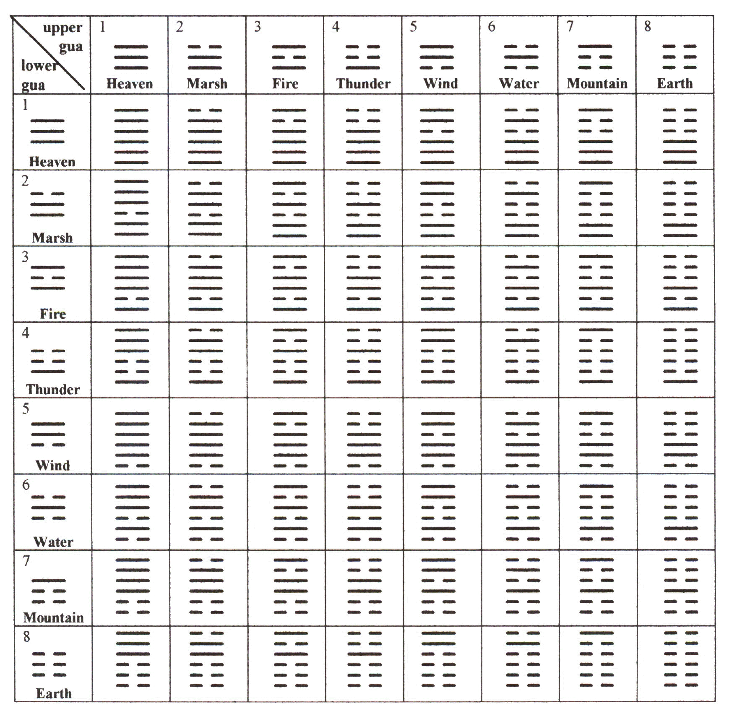
Interpretation of the 64 signs presented at www.astro-fengshui.com

There was mention of the importance of divination in other cultures, in particular the Romans reliance on inspection of the liver of sacrificed animals and on sightings of birds to determine the gods’ will or predict the future. The nearest parallel to the I-Ching itself might be the Librī Sibyllīnī (Sibylline Books), a collection of Greek hexameters supposedly made originally at Gergis on Mount Ida near the ancient site of Troy. They eventually reached Cumae in Italy and the set of nine books was said to have been offered to Rome’s last king, Tarquinius Superbus by the Cumaean Sibyl (prophetess). When he refuse to pay the high price demanded, she twice burned three of them, each time asking the same amount for the rest. He finally agreed to pay the original asking price just for the remaining three! The books were used for determining what action should be taken to ward off ill omens etc. when they were destroyed by a fire in 83 B.C., a new collection was made in Greece to replace them. See for more details http://en.wikipedia.org/wiki/Sibylline_Books

We also discussed the Latin for curry (the English word itself derives from the Tamil kari, `sauce used with rice’) One possibility is iūs acre (`spicy sauce/soup’). Stefan has been compiling a German-Latin glossary of all the food terms and other items that have come up in our discussions. Unfortunately he does not at present have the time himself to type this out and add English.

Kristina asked if there was anything for Latin available similar to Roget’s Thesaurus for English, which groups synonyms and words of similar meaning. Stefan referred to one published in Germany. An internet search revealed Matthias Hengelbrock’s Thesaurus Latinus http://www.amazon.de/Thesaurus-Latinus-Vokabeln-Formen-Nachschlagen/dp/3525257007
However, this seems to be more of a Latin-German dictionary, sometimes offering more than one German equivalent of a Latin term but not grouping together similar Latin terms.

We also briefly discussed Latin drinking songs, the most famous of which is `Gaudeamus Igitur’, used also on relatively solemn academic occasions in many universities. The tune is also used in Brahm’s Academic Festival Overture. The words in full are at http://en.wikipedia.org/wiki/Gaudeamus_igitur
and there are links to various performances at http://linguae.weebly.com/latin--greek.html including one of the best-known first stanza by Mario Lanza http://hk.youtube.com/watch?v=WfGXYkfLJ4s&feature=related

Gaudeamus igitur
let-us-be-happy therefore
Iuvenes dum sumus
young while we-are
Gaudeamus igitur
Iuvenes dum sumus
Post iucundam iuventutem
after pleasant youth
Post molestam senectutem
after miserable old age
Nos habebit humus.
us will- have earth
Nos habebit humus.

Don and John managed to sing this at a recent barbecue, when the Brits, by then sufficiently well-oiled, needed to match the Moravian contingent’s folk singing. Happily, no recording was made. For other Latin songs (e.g. `Bacchus bene venies’), sung by professionals, see http://linguae.weebly.com/corvus-corax.html

Another stanza pf `Gaudeamus’ wishes an ill-fate on `antiburscius’, i.e. anybody opposing the student fraternities (Burschenshaften) founded in Germany in the 19th century. Stefan explained that these were drinking societies but also liberal in political outlook and active in the attempted revolutions of 1848. Abolished (like other youth institutions) in the Nazi period they were later re-established but now tend to be right-wing. More detail at http://en.wikipedia.org/wiki/Burschenschaft

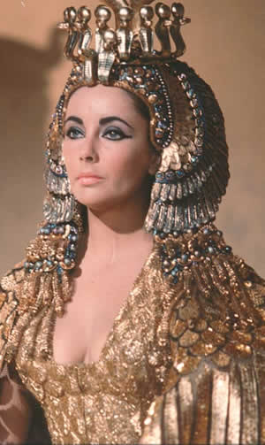
Cleopatra, as portrayed by Elizabeth Taylor
Don also mentioned `Nunc est bibendum’, which is actually the opening phrase of an ode by Horace (Book 1, 37) celebrating the defeat of Cleopatra in 31 B.C. (in accordance with the political line taken by Horace’s patron, Octavian (the future Augustus) the Egyptian queen, not Mark Anthony, was portrayed as the principal enemy). The first stanza, with literal translation:

Nunc est bibendum, nunc pede libero Now there should be drinking, now with free foot
pulsanda tellus, nunc Saliaribus the earth should be struck, now is high time to deck
ornare puluinar deorum the gods’ couch with the Salian feast, comrades
tempus erat dapibus, sodales.

The Salii were priests of Mars and their procession was famous for the sumptuous feast provided.
QUESTIONS ARISING FROM 32rd. MEETING, 28/6/13

We looked at some of the Latin materials relating to China which John had prepared for the Latin course organized by Fr Louis Ha this month at the Hong Kong Centre for Visual (the handout is reproduced below and the full collection is available at http://linguae.weebly.com/sina-latina.html). These included Virgil’s reference in the Georgics to the Sēres combing off `thin fleeces’ (i.e. the cocoons of the silk worm) from leaves. The word presumably derives ultimately from the Chinese for silk絲 (sī) and was borrowed via Greek (hence the short `e’ in the plural ending). The earliest known use of the Greek term is by the geographer Strabo, a contemporary of Virgil’s, but it is likely to have been use long before that as import of silk into the Mediterranean region started well before the 1st century B.C. The passage from Pliny the Younger, who wrote about a century later and placed the `Seres’ accurately on the east coast of Eurasia, shows cynical amusement at the immense effort that went into importing the raw silk, unwinding the cocoon and weaving the fabric so that Roman ladies could wear see-through clothing in public – the Latin verb trāluceō (< trānsluceō) means `be transparent/ translucent’ and not (as John originally thought) `be resplendent’ This quality of silk garments was often denounced by Roman moralists, but we have yet been possible to track down the Latin original of this quote that appears on http://en.wikipedia.org/wiki/Romano-Chinese_relations and several other websites:

I can see clothes of silk, if materials that do not hide the body, nor even one's decency, can be called clothes. ... Wretched flocks of maids labour so that the adulteress may be visible through her thin dress, so that her husband has no more acquaintance than any outsider or foreigner with his wife's body.

This is supposedly from volume 1 of the `Declamations’ of Seneca the Younger, presumably a muddled reference to his father, Seneca the Elder, author of .

Although Roman discussion always focuses on women’s use of silk, it was also sometimes used by the other sex and Tan recalled hearing somewhere that Julius Caesar had a garment made of it.

China long tried to keep the secrets of silk production to itself and one of us suggested that at an earlier stage silk was only produced in one particularly region which similarly tried to stop the techniques of Sericulture spreading to other parts of China. The gweilo apparently only got hold of silk worms in the 6th century when Byzantine monks smuggled them out of China hidden inside bamboo staffs (see http://en.wikipedia.org/wiki/History_of_silk ) It is possible, however, that an inferior kind of silk was made in ancient Greece from the cocoons of a wild moth on the island of Cos (see http://en.wikipedia.org/wiki/Coa_vestis )

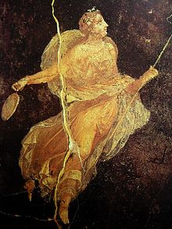

The Tang dynasty writer Jia Dao’s poem translated by Massimo Scorsone is a very well-known one and Wei pointed out that it is in the common classical format of four lines of five-characters each, with the second and fourth lines rhyming (the vowel sounds of 去 and處 are identical in Mandarin (qù and chù) though not in Cantonese (heui and chyu) ) and that the theme of fruitlessly searching for someone is a very common one in classical Chinese poetry. He also said that the English translation of the title (`Seeking the Master but not Meeting’) is not accurate as the character means a renouncer or hermit and is thus better represented by the Latin anachōrēta

The Jesuit astronomer Adam Schall’s Latin version of the Chinese lines in his own honour presented to him by the Emperor Shunzhi is described by its Japanese editor as probably the earliest Latin translation of a classical Chinese poem. However, Wei thought that a string of four-character phrases of this type was really a stylized prose eulogy rather than poetry (詩) in the strict sense.

In discussion of cultural exchange involving early European visitors to Chine, Wei said that he had read somewhere that the Emperor Kangxi, who as a prince had been tutored by Adam Schall, took Latin lessons for some time, the evidence for this presumably being in the emperor’s official diary. Mention was also made on an earlier traveler, Marco Polo, whom the British Sinologist Frances Wood believes never got to China but fabricated his memoirs from hearsay. One of her arguments is that Marco Polo makes no mention of foot-binding which was probably widespread in China by the 13th century (details of her book are at http://www.amazon.co.uk/Did-Marco-Polo-Go-China/dp/0813389992/ However, Wei believed that the celebrated 18th century Chinese novel Dream of the Red Chamber (紅樓夢), although focusing heavily on women, is also completely silent about foot binding.

We also briefly discussed the queue (or `pig-tail’), an important cultural feature of the Qing period and had to be worn by everyone except the emperor himself. Whilst forcing the Han Chinese to adopt Manchu hairstyle and dress, the Qing also ensured that the Manchu did not adopt foot-binding, a decision which helped maintain social segregation and the ban on inter-marriage between the conquerors and conquered

We talked about the Roman verbs for marry, which were different for men and women. The man was said to `lead a woman into marriage’ (in mātrimōnium dūcere) or `lead a woman (off) as a wife’ (uxōrem dūcere), or dūcere could be used on its own For women the verb nūbō (nūbere, nūpsī, nūptum) was used with the husband in the dative case, So if Gaius and Gaia got married:

Gaius Gaiam (in mātrimōnium) dūxit. OR Gaia Gaiō nūpsit

As usual phrases for food and drink were considered and members were reminded of the indispensable sentence Bibisne vīnum rubrum? (Do you drink red wine?). The menu included Peking duck (anatīna Pekinēnsis), taro (colocāsia) and mushroom (fungus)

Finally, Tan mentioned a logo from scriptwriter Dan Harmon’s website. With the motto `Scribimus Latinum sine intellectum’ (i.e. `We write Latin without understanding’). As sine (without) takes the ablative, the correct from of the supine intellēctum would be intellēctū. An alternative would be to use the ablative of the gerund (intellegendō)


Virgil (Publius Vergilius Maro), Georgics, II, 120-1
Virgil (70 B.C. – 19 A.D.), Rome’s greatest poet, mentions the Sēres as producers of silk in a section of his didactic poem the Georgics (`On Farming’) where he talks about the different products of different regions. Although Sēres did certainly come to mean specifically the Chinese, it is possible that in this and other classical authors the reference is to another people somewhere along the Silk Road. The Georgics were probably completed in 29 B.C., two years the civil wars ended with Augustus’s defeat of Anthony and Cleopatra at Actium.

quid nemora Aethiopum mollī cānentia lānā,
uelleraque ut foliīs dēpectant tēnuia Sēres?

Pliny the Elder, VI, 20
Gaius Plinius Secundus (23 – 79 A.D.) was a military officer and all-round scholar, whose Naturalis Historia is a compendium of information on geography and many other subjects. His general conception of Eurasia is similar to Mela’s a generation before but he provides much more detail, including a rather irreverent account of the production and conmnsumption of silk. He died during the eruption of Vesuvius which destroyed Pompeii and Herculaneum in August 79 B.C. and a detailed account of his final hours has been left by his nephew, Pliny the younger.

20. [[54] prīmī sunt hominum quī nōscantur Sēres, lāniciō silvārum nōbilēs, perfūsam aquā dēpectentēs frondium cānitiem, unde geminus feminis nostrīs labos redordiendī fīla rursusque texendī: tam multiplicī opere, tam longinquō orbe petitur ut in pūblicō mātrōna trāluceat. Sēres mītēs quidem, sed et ipsī ferīs similēs coetum reliquōrum mortālium fugiunt, commercia exspectant.

Massimo Scorsone, translation of `Seeking the Master but not Meeting’
Scorsone’s Latin version of these verses by a Tang dynasty poet, Jia Dao (779 – 843 A.D.), was one of several he published in the Italian journal Semicerchio (XXXIV, 2006) and also made available at http://www3.unisi.it/semicerchio/upload/sc34_scorsone.pdf A more literal English translation is given at http://en.wikipedia.org/wiki/Jia_Dao More of Scorsone’s translations can be read in VATES,an on-line journal of Latin poetry (http://pineapplepubs.snazzystuff.co.uk/Vates%20issue%204.pdf). He is also the author of an extended Latin account of the poet Li Po (李白) and his work.



THYIADII
(Chia Tao)
Anachōrētam quemdam quaerit poēta,
neque tamen invenit
Pīnūs subter, ab asseclā
Dēsertī dominum jūre requīrimus.
Is vērō «Procul hinc pater:
Herbās jam medicās ipse per ardua
Terrārum, atque virentia
Collectūrus abit, nūbibus abditus
Spissīs,» inquit, «et āëre.
Quō sēcēdat... iō! mē penitus latet.»

Adam Schall, Immensa Caeli Machina
This poem in honour of Adam Schall(湯若望, 1592-1666), the Jesuit astronomer who supervised the Imperial Observatory in Beijing for many years was written by the first Qing emperor of China, Shunzhi (順治, reg. 1644-1661), or perhaps rather by a court poet, and then translated by Schall himself into Latin The text in both languages, downloaded from http://www.ne.jp/asahi/harada/latin/poet1.html on 8/6/13, was originally published in the journal 言語文化研究 (vol. 22（1996）153-170) by Professo H. Harada who added a Japanese translation and believes this may be the earliest example of a Latin translation of a poem in classical Chinese. The website includes recordings of the poem in Windows Media Player and Real Player versions.
大園在上 Immēnsa caeli māchina immense machine of heaven
周廻不已 numquam rotandō dēficit, never in-rotating fails
七精之動 planēta quisque proprium planet each special
經緯有理 eundō mōtum cōnficit. in-going motion completes
庶績百工 Hinc omne quod coelō subset hence all which heaven is under
於焉終始 ortum exitumque postulat; origin and end requires
有器有法 ars cuncta deinde māchinīs all art then by-machines
爰觀爰紀 observat atque supputat. observes and calculates
惟此遠臣 Eurōpa nōbīs hospitem Europe to-us guest
西國之良 submīsit isthūc inclytum, has-sent from-there famous
測天治歴 sunt astra et hōrum calculus are stars and calculation of-them
克殫其長 statim reducta in integrum. at-once reduced into a-whole
敬業奉神 Ut mūneris sīc Nūminis as-of-duty thus of-Deity
篤守弗忘 oblītus haud unquam suī, forgetful not ever his
乃陳儀象 dum debitum signīs sacrīs while due to-signs sacred
乃構堂皇 templōque cultum praeparat. and-to-temple worship he-prepares
事神盡虔 Dum sēdulus servit DEŌ while painstakingly he-serves GOD
事君盡職 et mūnus exaequat suum, and duty fulfills his
凡爾疇人 Chinēnsibus et Tartarīs for-Chinese and for-Tartars
永斯矜式 tum fōrma vīvit actuum. Then form lives of-acts

QUESTIONS ARISING FROM 33rd. MEETING, 30/8/13

We discussed extracts (see below) from the late David Morgan’s essay on Historica Narrātiō, the account by the 17th century Jesuit astronomer Adam Schall, who was the only foreigner to be appointed head of the imperial Chinese governments Astronomical Bureau, responsible for ensuring the accuracy of the calendar. He is, after Matteo Ricci, the most celebrated of the Jesuit (`Society of Jesus’ – S.J.) missionaries who exercised such great influence in the Beijing court in the closing year of the Ming dynasty and the opening ones of the Qing. Jealousy among Chinese courtiers led to Schall and other Jesuits being condemned to death on a charge of contributing to the death of the Empress by delibearately miscalculating the time for a funeral but an earthquake the following day led to the sentence being commuted. The Jesuits were released but Schall’s health had suffered and he died in 1666, within a year of his release from prison. The full text of Morgan’s article is available in the SINA LATINA document already distributed to Circulus members and details of Schall’s life are available at http://en.wikipedia.org/wiki/Johann_Adam_Schall_von_Bell

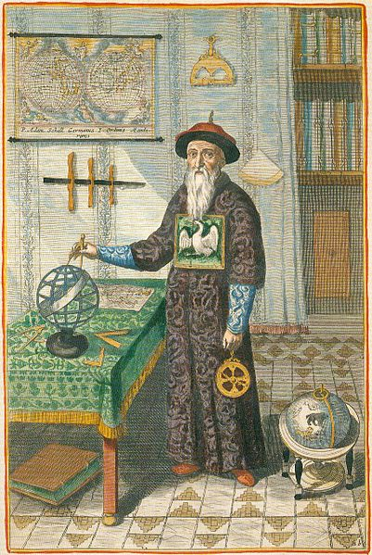

The Jesuits’ success was due both to their profound knowledge of astronomy and other sciences and to their willingness to assimilate into Chinese culture. In addition to adopting Chinese dress and learning the language fluently, they argued that the traditional rituals honouring ancestors and Confucius did not constitute worship in the full sense and therefore were compatible with the Church’s teaching,. The rejection of this view by the Catholic Church at the beginning of the 18th century (a decision formally rescinded in 1939) led to the banning of Christianity by the government

Wei mentioned that the first Jesuit to gain influence at the court, Matteo Ricci spoke a dialect intermediate between French and Italian, though he generally conducted his correspondence in Latin. As a German, Schall probably used Latin for oral commiunication with his Italian colleagues. Latin retained an important official role in some parts of Europe until quite late, being, for example, the language in which parliamentary proceedings were recorded in Hungary and elsewhere down to the revolutions of 1848. Both Ricci and Schall wrote extensively in Chinese, of which the latter had the better command.

Wei also said that in one letter Ricci compared Indian, Japanese and Chinese society and described the Chinese as being the most advanced. He had himself lived for some years in India but relied on others’ reports for his knowledge of Japan. Schall also entered China from India as there was at this time an agreement between the Catholic Church and Portugal under which all missionaries bound for China traveled via Goa. The Vatican later pulled out of the agreement when the Portuguese began exacting unreasonable fees. At this period there was a general system of agreements providing for Catholic secular powers to facilitate missionary work in return for giving the government some say in ecclesiastical appointments.

We also discussed the resentment against the Jesuits felt both by some other parts of the Church and by major European powers. These led eventually to the suppression of the Jesuit Order from 1773 to 1814 although it was allowed to continue its activities in Russia and Poland, The Jesuits were frequently accused of making two many compromises in order to win converts and of a general Macchiavellian approach to achieving their aims. Hence the old tag Diabolus est Iesuīta, ita, ita (The devil is a Jesuit, yes, yes!’ The `i’ of ita, though short in classical Latin, is pronounced long in Church usage).

Pro- and anti-Jesuit sentiments are reflected in the large number of jokes about the order. One concerns a dispute in heaven between the Cistercians and Franciscans on which of the two orders had the higher status. As the argument continued, a memo arrived reading `My dear children, stop this nonsense! I love and value you all equally.’ It was signed `God, S.J.’ In another anecdote a Jesuit enters heaven amidst the sound of trumpets blaring and angels singing. A Franciscan complained to St. Peter that he himself had received no such splendid reception and that it was unfair Jesuits should get superior treatment even in heavan. The reply was: `You don’t understand. A Franciscan arrives here almost every week, but God knows how long it is since we had another Jesuit get in!’

The Jesuits were involved as interpreters and drafters of the 1689 Treaty of Nerchinsk between China and Russia and also in the negotiation of later agreements. Wei noted that in treaties beween Britain and China there were often major discrepancies between the Chinese and English texts.

On the food side we only discussed the translation of `red bean soup’, which should perhaps be iūs fabārum rubrārum. The word faba has probably been burned into everybody’s consciousness, however little Latin they have studied, because of its use in the song from the soundtrack of `Mr Bean’, Ecce homō quī est faba (`Behold the man who is a bean’), which can be heard at
http://www.youtube.com/watch?v=1XsYnux-OSc

Extracts from David Morgan, `Dē Adami Schall Historicā Nārrātiōne: Quō Modō Sīnae Sint Latīnae Factae’
David Morgan (1959 -2013) was Professor of French at Furman college in the USA but his main scholarly interest was in neo-Latin literature and the promotion of spoken Latin. In this undated essay, available on the web at http://mcl.as.uky.edu/schall, he discusses Schall’s description of China, highlighting the way in which the Jesuit astronomer sought to equate many features with those of the Roman Empire. In seeking out such parallels he was unconsciously replicating the approach of the Chinese themselves in the Han dynasty, when the Roman empire was known as Da Qin大秦.

Annō 1665 typīs excussus est Vindobonae in Austriā liber quī inscrībitur Historica Narrātiō
dē Initiō et Prōgressū Missiōnis Sociētātis Iēsu apud Chīnēnsēs, ac Praesertim in Rēgiā
Pēquīnēnsī, ex Litterīs R. P. Iōannis Adamī Schall, ex Eādem Sociētāte, Suprēmī ac Rēgiī .
Mathēmatum Tribunālis Ibidem Praesidis. Quī liber pars est ingentis ac pretiōsissimī illīus
librōrum epistolārumque corporis, quō Sociētātis Iēsu missiōnāriī ab saeculō 16ō usque ad
18um dē mōribus natiōnum eārum, ad quās missī erant, dīligenter rettulērunt - quā in rē nōn
tantum Sociētātis conditōris, Ignātiī dē Loyōla, praeceptum exsecūtī sunt, vērum etiam
anthrōpologiae modernae velut fundāmenta posuērunt.

[M]issiōnāriī… cum dē Sīnēnsī linguā, cultū deōrum, aedificiīs, rēgimine, aliīsque
eiusmodī accūrātissime nārrāvērunt, tum methodōs suās doctrīnamque et theologiam
prōpugnāre ēnīsī sunt, nempe populī suffrāgium benevolentiamque captantēs. Arduum enim
sustinēbant bellum eā fere tempestāte contrā Iānsenistas imprīmīs, quō bellō nōn iam in
aulīs academicīs sed in pūblicō dīmicātum est - tēlō adhibitō potissimum prēlō typographicō.

Matthaeus Riccius, Iēsuīta erūditissimus, mathēseōsque imprīmīs perītus, exeunte saeculō 16 ad urbem Pēkīnum usque pervēnit, atque acceptus est in aulam imperiālem. Pater Riccius magnā cum astūtiā scientiam Eurōpaeam astronomicam pariter ac mathēmaticam ad fidem tūtēlamque imperatōris merendam adhibuit. Librīs autem Sīnicē scrīptīs doctrīnam occidentālem tam sacram quam philosophicam et mathēmaticam Sīnēnsibus aperuit; īnsuper librīs Latīnīs cultum Sīnēnsem praesertimque Confuciānismum Eurōpaeis exposuit….

Adamus Schall, Germānus, … mediō saeculō 17 nōn sōlum in amplissimum mandarinōrum
gradum prōmōtus est, vērum etiam tribunālī astronomicō imperiālī praefectus - quod in omnī
memoriā numquam hominī exterō contigerat. [L]iber aliquātenus vītae eius nārrātiō est...[sed] amplior nārrātiō ex hōc cōnstat, quod cultus cīvilis Eurōpaeus cēterōs omnēs cultūs - etiam vetustissimōs, tamquam Sīnēnsem - paulatim, et fātālī quōdam impetū, nōn tam exstinguere quam complēre quōdammodō ac perficere ostenditur. …

[Est nārrātiō quasi dēcolor; id quod ex Romanticismī tempestāte "colōrem locālem" vocāmus, huic relātiōnī omnīnō dēest. Vix ūllum vocābulum offenderēs quod non sit pūrae et antīquae Latīnitātis; ūsūrpantur plērumque vocābula antīqua ac rēs Rōmānae, ad hominēs mōresque Sīnēnsēs dēpingendōs.
Quārē scrīptor verba peregrīna effugit, rēsque Rōmānās beneque nōtas adhibet, quoad potest,
ad cultum Sīnēnsem expōnendum?

- primum … hūmānistae…, idest temporis Renāscentiālis ērudītī, ad ūniversālitātem quandam tendēbant, idque sōlum iīs scītū memorātūque dignum vidēbātur, quod genus hūmānum ūniversē et generāliter attingeret. Porrō ad facta gestaque hūmāna generāliter,
exprimenda hūmānistīs impromptū erat mīrē idōneum instrumentum, scīlicet sermō Latīnus,
quippe quī nōn unīus patriae proprius esset, nōn ūnius aetātis, sed ūniversālis et aeternus.

- Altera causa ex rixīs ecclēsiasticīs exoritur. Cēterī in Sīnīs operantēs missiōnāriī,
Iēsuītās accūsant quod rītūs pāgānōs et īdōlolatrīam inter prosēlytas eōrum patiantur; Iēsuītae respondent cultum maiōrum apud Sīnēnses doctrīnamque Confūciānam nōn esse īdōlolatrīam, sed venerābilem quandam philosophiam, cui dēsit tantummodo Christiānae revēlātiōnis plēnitūdō. Quam ob rem Iēsuītārum interest efficere ut mōres cultusque Sīnēnsis nōn insolitus, nōn exōticus, sed potius Eurōpaeō similis videātur. Ad hunc fīnem spectat ūsus illīus quasi ūniversālis Latīnitātis hūmānisticae….

Sīnae hōc librō ante omnia tamquam locus clausus dēpinguntur. Prīmum, tōtum imperium
Sīnēnse exterōs peregrīnōsque sub poenā mortis exclūdit, sōlīs Iēsuītīs exceptīs. Cēterī
missiōnarii, Franciscānī et Dominicānī praesertim, ūnā cum mercātōribus in oppidis
lītorālibus quibusdam manēre ac tabēscere coguntur. Deinde urbs caput Pēkīnum ipsīs
Sīnēnsibus clauditur, nisi paucīs…. Sed ad tot materiālēs mūrōs accēdunt etiam artiōra mentis et animī claustra. Sīnēnsēs enim exterōrum mōres contemnunt, et "superbē plūs cēterīs mortālibus sapere sē sōlōs crēdunt." A novitāte abhorrent, "nec dēviant a rēgulīs mōribusque maiōrum." Postrēmō additur linguae Sīnicae singulāritās et difficultās, quae missiōnāribus impedimentō est immēnsō….
Quōmodo vērō ā Patre Schall Iēsuītārum opera dēpingitur? Reperiuntur in librō duo verba
frequentissimē: "penetrāre" et "īnsinuāre"; exemplī grātiā, "Patres se īnsinuāvērunt,"
"Christiāna lēx in aulā rēgiā īnsinuātur"….

Diē ….. quōdam, purpurātīs omnibus ipsōque imperātōre spectantibus, inter eclīpsem Pater Adamus cum prīmō mandarinō "speculam mathēmaticam cōnscendit; cōnstat sōlum novum ab Eurōpaeīs trāditum calculum tam temporī quam punctīs eclipticae exactē respondisse," et antīquam Sīnēnsem rēgulam ūnā hōrā ā vērō discrepāsse….

Ultimīs tandem librī capitibus ipse imperātor Patrī Adamō ānsam praebet, ut quid de nūmine
divīnō cēnseat, expōnat. Haec colloquia verbōtenus referuntur, quibus in ipsō umbilicō
Sīnēnsis imperiī doctrīna Christiāna ēnūcleātur. Dubitat imperātor, titubat. In hōc rērum
discrīmine - ac librī catastrophē - subitō corripitur imperātor ignōtō morbō, paucīs diēbus
ēmoritur.
Capitulō extrēmō nārrantur fūnerālia singulīque rītūs et caerimōnia - haec est librī quasi
perōrātiō - sed ultimīs librī pāginis lector sentit nārrātōrem nōn iam intuēri sōlum, sed plēnē
participāre vītam et cultum Sīnēnsem. Sānē orbis cultusque ille artissimē clausus, in quem
Pater Adamus tot labōribus penetrāverat, in Patrem ipsum quoque penetrāsse vidētur, qui
quōdammodo Sīnēnsis factus est….

TRANSLATION

In 1665 there was printed in Vienna in Austria a book entitled Historical Narrative of the Beginning and Progress of the Mission of the Society of Jesus among the Chinese, and Especially in the Palace in Beijing, from the Letters of the Reverend Father John Adam Schall, of the same Society, Chairman of the Supreme Royal Mathematical Board in the Same Place. This book is part of the huge and most valuable corpus of letters and books in which between the 15th and 18th centuries the missionaries of the Society of Jesus diligently reported on the customs of those nations to whom they had been sent, In this undertaking they not only carried out the instruction from their founder, Ignatius de Loyola, but also indeed in a way laid the foundations of modern anthropology.

At the same time that they gave a very accurate account of the language, religion, architecture and government of China, the missionaries also strove to champion their own methods, doctrine and theology, clearly seeking to obtain popular support and goodwill. For they were at that time in a strenuous conflict, particularly against the Jansenists, a conflict in which the fighting did not now take place in the halls of academia but in public, with the printing press the weapon most employed.

Matteo Ricci, a highly learned Jesuit, and particularly skilled in mathematics reached the city of Beijing at the end of the 16th century and was accepted into the Imperial court. Fr. Ricci, with great astuteness, made equal use of European astronomy and of mathematics to earn the confidence and protection of the emperor. Moreover, in his Chinese writings he revealed to the Chinese western teaching, both religious, philosophical and mathematical, whilst in addition in his Latin books he expounded Chinese culture, especially Confucianism, to the Europeans.
In the middle of the 17th century, the German Adam Schall was not only made a mandarin of the highest rank, but was actually placed in charge of the Mathematical Board, something of which there in no record of ever having happened to a foreigner. His book is in a way the story of his own life but the larger narrative consists in a demonstration of how Western civilisation, gradually and by a stroke of fate, not so much extinguished but in a way completed and perfected all other civilisations, even the oldest amongst them, such as the Chinese.

The narrative is in a way a colourless one; that which since the Romantic era we have called `local colour’ is completely missing from his account. You would scarcely come across any word that was not pure, ancient Latin; use is generally made of ancient words and of Roman concepts to depict Chinese people and customs. Why did the writer shun foreign words and use, as far as possible, familiar Roman concepts, so far as possible, to give an account of Chinese civilization?

- first, the humanists … that is, the scholars of the Renaissance era, tended towards a kind of universalism and so the only that which was universally and generally relevant to the human race seemed to them worth knowing and recording. Furthermore, for expressing human deeds and achievements in a general way the humanists had at hand a wonderfully suitable instrument, namely the Latin language, since this was not the property of one native land nor of one age but was universal and eternal. .

a second cause arises from disputes within the Church.. The other missionaries working in China accuse the Jesuits of allowing pagan rites and idolatry amongst their converts; the Jesuits reply that the cult of ancestors amongst the Chinese and the doctrine of Confucianism are not idolatry but a philosophy worthy of respect, which lacks only the fullness of Christian revelation. For this reason it was in the Jesuits interest to ensure that Chinese customs and religious practice should not seem out-of-the-ordinary or exotic but rather similar to that of Europe. This was a reason for the use of a quasi-universal humanistic Latinity.

China is represented in the book as above all a closed place. First, the whole Chinese empire excludes foreigners and outsiders, the Jesuits excepted, on pain of death. Other missionaries, in particular the Franciscans and Dominicans, together with the merchants are forced to remain and waste away in the coastal towns. Then the capital city of Beijing is closed to all but a few of the Chinese themselves… But in addition to so many physical barriers, there were even tighter bonds of mind and spirit. For the Chinese despise the ways of foreigners and `proudly believe that they alone are wiser than other mortals’. They recoil from novelty `and do not deviate from the rules and customs of their ancestors’. Finally there is also the peculiarity and difficulty of the Chinese language, which is an immense hindrance to the missionaries. How indeed is the work of the Jesuits described by Fr. Schall? Two words occur very frequently in the book: `penetrare’ and `insinuare’; for example, `The Fathers insinuated themselves’, `Christian law is insinuated into the royal palace.’

On a certain day, with all the senior officials and the emperor himself looking on, in the midst of an eclipse Fr Adam with the senior mandarin `ascends the observatory platform; it is apparent that only the new calculation submitted by the Europeans corresponds exactly to the time and the extent (?duration) of the eclipse,’ and that the old Chinese rule is in error by one hour.

At last in the final chapters of the book, the emperor himself gives Fr Adam an opportunity to explain his thinking about the Deity. These conversations are reported verbatim and in them Christian doctrine is outlined at the very heart of the Chinese empire. The emperor is doubtful, he hesitates. At this critical point – and the climax of the book – the emperor is suddenly the victim of an unknown illness and within a few days he dies.

In the last chapter there is an account of his funeral with each individual rite and ceremony – this is in a way the book’s conclusion – but in the final pages of the book the reader feels that the narrator is not merely observing but fully participating in Chinese life and culture. Certainly that very tightly closed world and culture, into which Fr Adam had so laboriously penetrated, seems also to have penetrated the Father himself and he has in a way become Chinese.

QUESTIONS ARISING FROM THE 34th MEETING – 27/9/13

We practised some basic questions (Quid est tibi nōmen, Ubi nātus es? etc.) and responses, using a handout of phrases extracted from the list provided on the Circulus web-page - http://linguae.weebly.com/circulus-latinus-honcongensis.html. A passage from Kircher’s description of two Jesuit missionaries crossing the Himalayas in the 17th century (included in the letter of 25 September to the whole Circulus and also in the document SINA LATINA available from http://linguae.weebly.com/sina-latina.html ) was also distributed but not actually discussed.

We discussed the Latin names of CUHK – Universitās Sīnica Honcongēnsis – and of Clare College, Cambridge. Although John suggested Collēgium Clāriānum, consultation of 14th century foundress Elizabeth de Clare’s preface to the college statutes (included with some typos in the laest edition of the statutes themselves at http://www.clare.cam.ac.uk/data/uploads/about/history/clare_college _statutes.pdf) appears to show that her foundation was originally known as Aula Ūniversitātis (Univerity Hall) but that when increasing its endownment she decided it should be known in perpetuity as domus dē Clāre (Clare House)

Aulam Universitatis communiter hactenus nominatam, quae de nostra fundatione jam existit, et quam domum de Clare at non aliter volumus perpetuis temporibus nuncupari, in facultatibus de bonis nostris a Deo datis et in numero studentium fecimus ampliari,

The present-day English name `Clare College’ was officially adoped in the 19th century so, for a definitive answer we would need to consult Laitn documents mentioning the college after the change.

There should also be an officially uthorised Latin name for Harrow School but, in any case, the existence of the English adjective Harrovian presupposes a Latin adjective Harrōviānus, -a, -um.

For Mexico there is a generally accepted form: Mexicum, -ī n. (and adjective Mexicānus, -a, -um). Although Latin is not widely taught in Mexixo today, nor is it used in formal university ceremonies, a strong Latin literary tradition was established there and elsewhere in South America following the Spanish conquest. This is discussed by Rose Williams at http://roserwilliams.com/Latin.RomanIdealsHispanicNewWorld.pdf, which includes quotations from Mexican Latin writers Rafael Landivar, Jose de Acosta and Don Francisco Cabrera. There is also an extensive discussion of the use of Latin in the region in Nick Ostler’s history of the language Ad Infinitum

David asked about the probable result of the referendum on independence to be held in Scotland in 2014. Although opinion polls normally show most Scots have a greater emotional attachment to a `Scottish’ rather than `British’ identity, this does not necessarily translate into support for independence since the decisive factor here is probably economic and this is difficult to calculate reliably. At the moment, it looks as if the result could go either way.

The union of England and Scotland to form the `United Kingdom of great Britain’ took place in 1707, when the main factor was far among the Scottish ruline classes of being shut out from English markets if they did not agree to the merger. For a century before then, the two countries had shared the same monarch but retained separate parliaments and the term `Great Britain’ had been introduced unofficially by King James VI of Scotland who became also Jamnes I of England on the death of Queen Elizabeth in 1603, There is thus a contrast between the Scottish case and that of Catalonia in north-east spain, where there is a similar strong sense of separate identity but also memories of the outright physical conquest of the region by the cental government in 1714 at the end of the War of the Spanish Succesion, and again in 1939 with Franco’s victory in the Spanish Civil War.

The Latin for Scotland is Calēdonia, -ae f (note the short o’ in contrast to the long one in the English derivative `Caledonian’. The etymology of the wordis uncertain: an older theory linked it with the Welsh celydd (a woody shelter) an Latin cēlō (I hide) but a later one suggests an origin in the P-Celtic caled (hard), which may itself be a loan from a pre-Celtic source (see http://athirdway.com/glossa/?s=Caledonia and http://en.wikipedia.org/wiki/Caledonia )

John showed some slides from INTRODUCTIO PERSONALIS, two of which include an explanation of the composition of the United Kingdom:

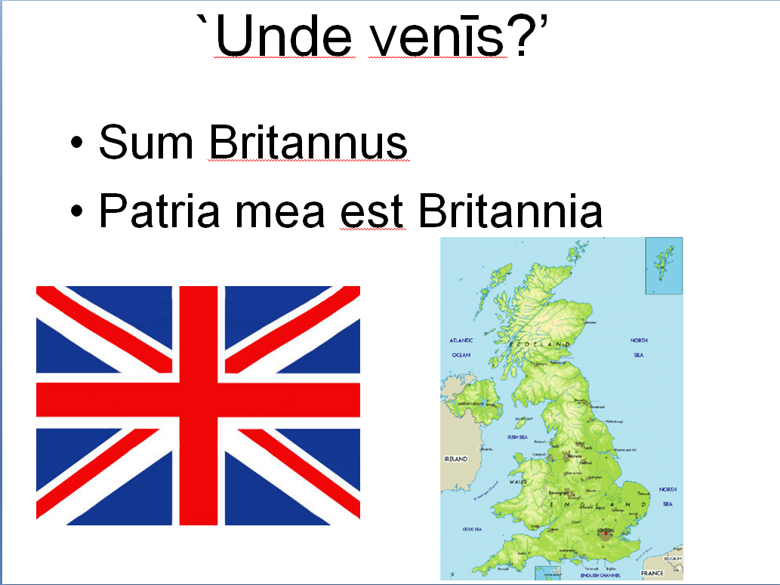

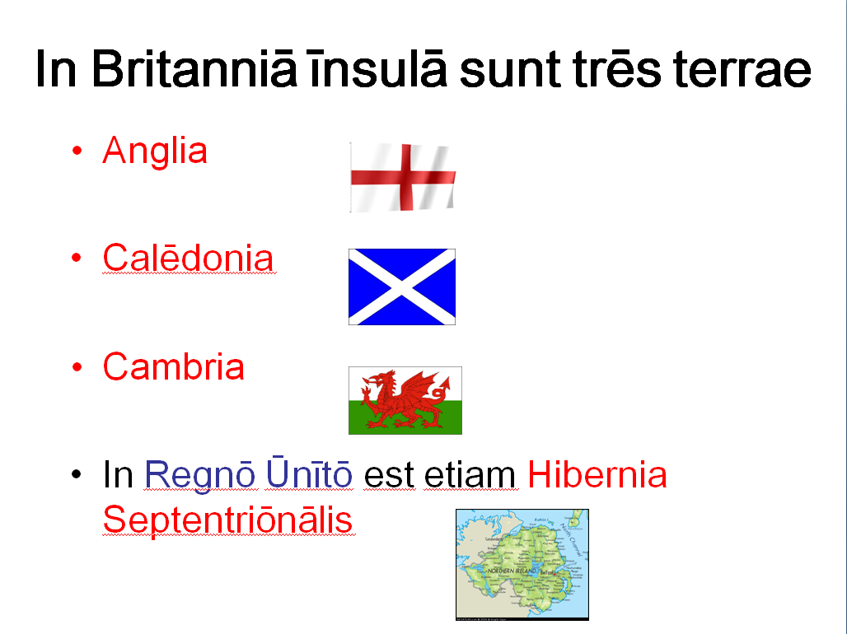

Philip pointed out that the Union Jack on the first slide is upside-down (the broader white section on the top-left arm of the diagonal cross should be above the red, not below), something which John, as a former Boy Scout, should have noticed himself! It was also pointed out that the adjective Ūnītum in Regnum Ūnītum is un-classical and that the section of the 1952 Act of Parliament setting out Queen Elizabeth II’s official titles gives the phrase omnēs Britanniae (`all the Britains’, i.e. all the islands in the archipelago) as the Latin equivalent of United Kingom.)

We also discussed `vulgar Latin’ (the colloquial speech from which the modern Romance languages derive). Philip wondered whether this observed the predominant subject-object-verb (SOV) word order of literary Latin. John thrght that it originally did (and pointed out that SOV order is by no means uncommon in the world’s languages and I still used today by Japanese and most South Asian languages (including Hindi and Nepali). However, the SVO order found in the descendant languages is evidence that the switch was made before the brek-up of spoken Latin in late antiquity. Both the reduction of the case system (to a binary nominative-accusative one, an then to the complete elimination of case-inflection) may have been driven by the needs of large numbers of adult second-language learners entering the Latin speech community (see http://cnl.psych.cornell.edu/pubs/2010-bc-EvoLang.pdf ). We also noted the frequent vocabulary differences between classical and vulgar Latin (e.g. for head, caput contrasts with colloquial testa (which originally meant a clay pot!) from which French tēte etc. derive. Also interesting is the fact that a number of nouns changed their gender in the transition from Latin to romance (e.g. arbor, arboris f. becoming l’arbre m. in French).

David played a section of the latest Nuntii Latini news broadcast (http://www.yle.fi/radio1/tiede/nuntii_latini/) from Helsinki on his i-phone and John pointed out that, although the pronunciation used is mostly (as their site claims) the classical one, the news readers follow the German (general north European?) tradition of using medieval `ey’ rather than the classical `ay’ for the ae diphthong. It is a mystery why the northerners decided to do this!

QUESTIONS ARISING FROM THE 35th MEETING – 18/10/13

As usual, we discussed the Latin for the things we were eating, including porcīna concīsa (minced pork), and gallīnācea spūtāns (`spitting chicken’ -口水雞 – on the menu!). The suggestion of piscis dulcis acerque was made for sweet-and-sour fish but sour is acidus rather than acer (which, when applied to food, can mean (spicy) hot) so this should really be piscis dulcis acidusque . Also mentioned, though not consumed, were farcīmen, farcīminis n sausage (botulus, -ī m, literally `intestine’, could be used with the same meaning (compare the Cantonese香腸 (`fragrant intestine’) but is rarer and regarded as impolite) and porrus, ī m or porrum, ī n, leek. We noted that terms like porcīna, būbula, gallīnācea (for pork, beef, chicken) are actually adjectives with the noun carō, carnis f (flesh. meat) understood. The full terms are thus analogous to Chinese牛肉 (beef) etc., though of course Chinese doesn’t have a separate adjectival form of the animal’s name.

We also briefly discussed the words spōnsus and spōnsa, which are masculine and feminine forms of the perfect participle of the verb spondeō, -ēre, -spopondī, spōnsum (promise solemnly (in marriage) and thus mean fiancé and finacée respectively. In the Romance languages, however, the meaning generally changed slightly to `husband’ and `wife’.

We wanted a word for thin (describing body shape) and macer (-cra, -crum) was chosen, though this is more commonly used of animals. strigōsus, -a, -um is used for a temporary state of thinness and another possibility is exīlis. gracilis can mean slim, slender.

As Kristina is of Lithuanian descent we discussed the correct Latin name for the country. Pat thought that, although Livonia strictly speaking referred to a separate region and people – a Finnic group whose language is almost extinct and whose territory is now split between Estonia and Latvia – Livōnia might have been used for `Lithuania’ in the Midle Ages. This seems, though, unlikely as the earliest recorded name for the country is Litua in a Latin chronicle composed in 1009 A.D., which uses the phrase in cōnfīniō Rūssiae et Lituae, `on the border between Russia and Lithuania’). This is clearly from a Slavicised form of Lithuanian Lietuva (see http://en.wikipedia.org/wiki/Name_of_Lithuania). Nuntii Latini, the Latin news service from Helsinki ,now uses the spelling Lituānia.

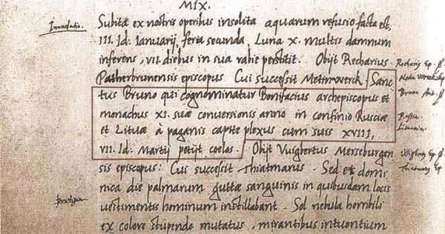
We looked at the new material on food and wine taken from letters to the Grex Latine Loquentium and now on our website (http://linguae.weebly.com/circulus-latinus-honcongensis.html) in the section Dē Rē Culīnāriā In the verses composed by `Laurentius’ brūma rather than hiems is used for winter. The former (derived from brevissima = shortest) originally referred specifically to the winter solstice. The author also uses the verb gignō, -ere, genuī, genitum (produce, beget). He refers to the sea with the name Amphitrītē (-ēs f), the wife of Neptune/Poseidon in classical mythology but originally an independent sea-godess. Some of us wondered whether there could be a connection between this name and that of Amphītryōn (or Amphītryo), -ōnis, the husband of Hercules’s mother, Alcmene. There does not, in fact, seem to be any conection and the amphī- element is simply a Greek preposition meaning around

Discussion of wintry weather led on to mention of Thūlē (-ēs f), an island mentioned by several ancient authors as lying north of Britain and variously identified with the Orkneys (though these were already in the 1st century A.D. known as the Orcades), the Shetlands, Iceland or the whole or part of Scandinavia. Bvirgil introduced the phrase ultima Thūlē, which was used figuratively to refer to an unattainable goal. In the Middle Ages Thūlē was sometimes use for Iceland and Ultima Thūlē for Greenland. We also talked briefly about the Icelandic sagas and someone mentioned Haldor Laxness, the Icelandic historical novelist, who won the Nobel Prize for literature in 1955.

We talked at length about the British history and place-names, particularly about the `Dark Ages’ in, when Germanic settlers became the dominant power in what is now England. Though most English placenames are now Germanic, `Kent’ (Latin Cantium) is definitely pre-Roman and the name `London’ probably derives from the Celti for `grey pool’, even though the city only became an important settlement under the Romans and archaelogists have yet to find evidence for earlier occupation.

There is an on-going argument amongst experts over how far the incoming Germanic settlers replaced the existing Celtic population in England (e.g. by mass killing, ethnic cleansing or simply because of a supposed collapse in Celtic population levels due to a plague) or how far Celts stayed where they were and gradually assimilated into the newcomers’ culture. Pat suggested that there was a tendency for English scholars to ignore evidence for the continung presence of the `Welsh’ in early England (the Old English term wealas (= foreigners) was used for all who continued to use the Celtic language (termed `Common Brittonic by modern scholars)’originally spoken over most of the island and now surviving in the form of modern Welsh.) This was certainly true in the 19th century, when many scholars believed in the racial superiority of Teutonic (Germanic) over Celtic people. A.E.Freeman, in his Old English History for Children (1869) (available at https://archive.org/details/oldenglishhistor00londuoft) wrote:

`…we may be sure we have not much of their [the Britons’] blood in us, because we have so few of their words in our language.. Now you will perhaps say that our forefathers were cruel and wicked men.. and so doubtless it was..But anyhow it has turned out much better in the end that our forefathers did thus kill or drive out nearly all the people whom they found in the land…[since otherwise] I cannot think we should ever have been so great and free a people as we have been for many ages.’

Understandably, given the events of the 20th century, this kind of racial theorising is no longer fshionable and John argued that there is no longer any poltical incentive to try to show that there was minimal blending between the two populations. In fact, it is in the interest of anyone trying to maintain the political unity of Britain (now under threat from separatism in both Scotland and Wales) to demonstrate as large as possible a shared heritage across the island.

In any case, the mainstream view amongst historians is now that there was not a complete replacement and that the majority of the ancestors of the present population of England were already in the country before the Anglo-Saxons arrived. This is based partly on estimates of the population of Roman Britain and of the likely size of the invading war bands but there is also genetic evidence to support it, even though there appears to be a higher proportion of Gerrmanic ancestry on the eastern side of the country than in the west. A recent example of this approach, focussing on a county on the east coast of England, is Thomas Green’s detailed study Britons and Anglo-Saxons: Lincolnshire 400-650 A.D. , for which an extensive preview is available on Google Books at http://books.google.co.uk/books/about/Britons_and_Anglo_Saxons_Lincolnshire_AD.html?id=727icUJrV80C and brief summary at https://delicious.com/Velptonius (22/10/13 entry).
For the argument that most of the ancestors of the presnt-day British arrived in the island around 14,000 years ago (which makes the Celtic language itself a later import) see the review of Steve Opppenheimer’s Origins of the British: a Genetic Detective Story at http://www.nytimes.com/2007/03/06/science/06brits.html?_r=1&th&emc=th&oref=slogin

This hypothesis of population continuity is still disputed (e,g by Nicholas Ostler in Empires of the Word) because of thr linguistic arguments Freeman relied on. However, although most placenames in central and eastern England (apart from rivers and a few very important cities) are Anglo-Saxon or Danish, this is not a decisive consideration as in the 9th century there was a major change on the settlement pattern, with people moving from smaller hamlets which were probably named after landscape features to larger villages that were named after the main landholder (see Robin Fleming’s Britain after Rome: the Fall and Rise). In addition, though the number of identified Celtic borrowings in English is small, there are features suggesting a Celtic sub-stratum, particularly the continuous tenses formed with a verbal noun (I am walking etc.) which are typical of Celtic rather than Germanic languages.

As a post-graduate student Pat spent several years studying the 7th century historyof his native Hampshire. Evidence from blood groups gathered in the 1920s sugested a contrast in the genetic mix between Dorset and Somerset on the one hand and Hampshire and Oxfordshire (where the proportion of invaders was presumably larger) on the other. As in Lincolnshire, many Hampshire streams had both Anglo-Saxon and British (Welsh) names. He also mentioned evidence of continuity in church buildings in different parts of the country. The cathedral at Wells is built on the site of an early 4th-century Celtic church, whilst at Exeter (and possibly Winchester) part of the old Roman forum was turned into a church. He also mentioned the 8th century historian Bede’s claim that Canterbury cathedral was built on the remains of a pre-Germanic church.

Pat also mentioned the 7th century Lincolnshire Saint Guthlac, who is said to have understood the Welsh-speakiing demons that hauntedf him in his hermitage. Although there is evidence in Green’s book for Welsh persisting till quite late in this region, the saint’s story is not really among this since his biographer, writing not long after his death, says that he had learned the language when in exile in a British-speaking area.

We also briefly discussed the regions other than Wales where British Celtic language and culture survived. Refugees from Britain during the invasions period established themselves in the area consequently called Bretagne (in English `Brittany’) in NW France. The present-day Breton language is a continuation of the ancient British not the Gallic (French) variety of Celtic, which was completely replaced by Latin. Breton is very close to the Celtic dialect of Cornwall, which died out in the 18th century (though there is currently an attempt to revive it). Pat and John stressed the remoteness of Celtic languages form English in their basic structure, including the feature of mutation (grammatically conditioned changes at the beginning of words): the basic forms of the Welsh words for country and fathers are gwlad and tadau respectively but in the first line of the Welsh national anthem (Hen wlad vy nhadau anwyl i mi, `The old land of my fathers is dear to me’) they become wlad and nhadau because they are preceded by adjectives.). There is a stirring performance of the anthem itself by Welsh opera star Bryn Terfel at http://www.youtube.com/watch?v=3kUnCwV3AYE&feature=fvw

We discussed the relationship between the main modern descendants of Latin. Spanish and Italian are much closer to each other than to French because the latter has changed more rapidly than they have. Both Italin and Spanish use si (from Latin sīc) for `yes’, whilst in the MiddleAges the north of France used oïl (from which the modern standard form oui developed) and the south oc. The oc from seems to have developed from the pronoun hoc (`this’) in sentences like hoc est and oïl from hoc ille (`this that’) in contexts like hoc ille fecit (`he did that’)

There was finally mention of Korean (Fiona’s native language). This is often viewed as a language isolate (not genetically related to any other known language) but there are some similarities both with the so-called Altaic languages (including Manchu and Turkish) and with Japanese.
QUESTIONS ARISING FROM THE 36th MEETING – 22/11/13

Although the meeting was our first at an Indian restaurant, we did not spend long discussing names for the dishes, but mention was made of the term pānis Persicus for naan (a large, flat piece of bread baked in Perisan style), used recently by a member of the Grex Latine Loquentium (an email forum for discussion in Latin – see http://www.man.torun.pl/archives/info/grex) Pānis tenuis (`thin bread’) was proposed for papadom, the crisp-like bread served with sauce as an appetizer. Along with naan (the word itself is simply the Persian for bread’ we ate ordinary boiled rice (orӯza) and pulao rice, which could perhap be termed orӯza cucurmāta (`rice with turmeric’), forming an adjective cucurmātus from cucurma, -ae f., the word for turmeric in 16th .and 18th century sources. As turmeric is also known as `Indian saffron’, another possibility might be orӯza crōcīnus (`saffron rice’).

David Morgan’s on-line `Lexicon Furmianum’ (http://millie.furman.edu/morgan/adumbratio.htm) has the following on the generic name for most spiced Indian dishes:

curry (dish) carium, i* n. (cf. Tamil kari, source of the European terms; Dutch kerrie; and earlier Fr. kari, Port. karil, now supplanted by the English form of the word) ► karri* indecl. (Georg Eberhard Rumpf, Herbarium Amboiense [Amsterdam, 1741], vol. 5, p. 166, quoted in Hobson-Jobson s.v. curry: "Indi enim ... adeo ipsi [scil. curcumae, i.e., "turmeric"] adsueti sunt ut cum cunctis admiscent condimentis et piscibus, praesertim autem isti quod karri ipsis vocatur." ►► The Tamil word kari simply means sauce; it was adopted in European languages as the name of a spiced Asian dish of meat or vegetables with rice.

The entry refers to Yule and Burnell’s Hobson-Jobson: a Glossary of Colloquial Anglo-Indian words and Phrases, published in the late 19th century but available in various reprints, a fascinating collection of linguistic and cultural information. A preview is available on-line at:
http://www.amazon.co.uk/Hobson-Jobson-Definitive-Glossary-British-India/dp/0199601135/
There is also a complete, easily searchable on-line edition at http://dsal.uchicago.edu/dictionaries/hobsonjobson/

As Pat was working on the catalogue for an exhibition of old photos of Hong Kong due to open at the History Museum on 25 December (http://hk.history.museum/en_US/web/mh/exhibition/current.html)
we discussed the Latin for `edit’ and settled on ēmendō (-āre. –āvī, -ātum), which is strictly `correct, repair’. The Latin verb ēdō, ēdere, ēdidī, ēditum (easily confused with edō, edere/ēsse, ēdī, ēsum, eat) is the origin of the English word but actually means `publish’,

Elizabeth, a new member, explained that she had originally taken up Latin hoping it would help her be accepted to study medicine but then greatly enjoyed the logical structure of the language. Most medical terms in English are Greek or Latin and there is a reference in Stevenson’s Treasure Island to a doctor who had turned to piracy as a learned man with `Latin by the bucketful.’ Prescriptions were regularly written in Latin into the 19th century and there were therefore textbooks of Latin for pharmacists. A relic of this practice survives in the term `stat’ (short for statim, at once) sometimes still written on patients’ notes when a drug is to be administered immediately.

Mike, another new member, explained that the class he was running at HKUST contained 18 students this year. All students at the university are required to study a language other than English or Chinese in their first semester and Latin was established as one of the options by Gregory James, who is now in retirement but still living in Hong Kong.

The merits of different authors for reading with students were briefly discussed. Although not as commonly used in schools at they once were, Caesar’s commentaries on his conquest of Gaul are written in very straightforward Latin and extracts are included in the current AP syllabus for American students (roughly the equivalent of British A-level). Chris was currently using Cicero’s Catilinarian orations (delivered in 63 B.C. when the author, as consul, thwarted Catalina’s attempted coup-d’état) and noted the very convoluted style, mentioning the joke about a senator who arrived fifteen minutes late to be told in a whisper by the man next to him `You’re alright. He hasn’t got to the verb yet!’ Pat argued that Cicero’s style would probably have made him incomprehensible to the man-in-the-street but John pointed out that at least one of the speeches against Cataline was delivered outside the senate house to an audience or ordinary citizens.

A recording of the whole of the first of the four speeches by Johan Winge, a Swedish expert on Latin pronunciation, is available on the internet at http://web.comhem.se/alatius/latin/incatilinam01.html Winge plausibly suggests that the speech is `quite possibly the most widely studied Latin text within elementary Latin education throughout the world’.Youtube has a reading of the opening sentences, accompanied by an animated image of Cicero himself: http://www.youtube.com/watch?v=iwNniFAnoFg

There was discussion of the Latin for `thank you’, which is grātiās tibi agō (I thank you), often abbreviated to grātiās (hence the modern Italian (grazie) and Spanish (gracias). Latinists nowadays would normally say grātiās maximās for `thank you very much’, even though there is a tendency for adjectives of size and quantity to go before rather than after the noun but Don pointed out this was far from a universal rule, as shown by the name Circus Maximus for the chariot-racing venue at the foot of the Palatine Hill:

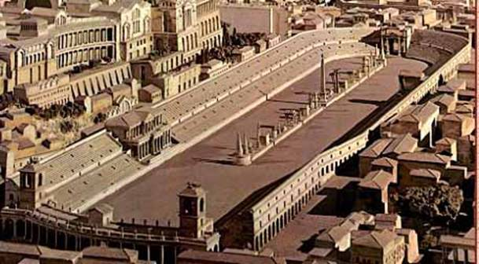
Circus Maximus (Domitian’s palace is on the Palatine hill on the left)

We also talked about the different styles of Latin pronunciation. The reconstructed (`restored’)classical pronunciation which most scholars now use is described in most textbooks and at many places on the Internet, including on the `Liinguae’ site: http://linguae.weebly.com/latin--greek.html The main differences between this and the `church’ pronunciation (sometimes also described as `Italianate’ or `medieval’) were set out in the record of our first meeting three years ago but are given here again for convenience:
Classical Ecclesiastical
c as in `cat’ like English `ch’ before `e’, `i’ or `ae’, elsewhere as `cat’
g as in `girl’ like English `j’ before `e’, `i’ or `ae’, elsewhere as in `girl’
v as English `w’ as English `v’
-ti-- with normal as `tsi’ or `si’
sound of each
letter
ae as in `die’ as in `day’
vowel length there are vowel length not important but stressed vowels generally longer
separate short
and long varieties
of each vowel

The authenticity of the `restored pronunciation’ is sometimes questioned (especially by Italians who want to go on pronouncing Latin as if it was Italian!) but the evidence is overwhelming and is set out in Sydney Allen’s book Vox Latina.

Winge’s pronunciation is extremely good for the individual sounds of the classical system and for elision between words but perhaps a better model for would-be Latin conversationalists is provided by American teacher Matthew Kiel. Though individual sounds are in the classical system, there is an Italian rhythm to his speech, which is probably similar to the way the ancient Romans actually spoke. See the embedded video (with transcription provided below and English sub-titles on the video itself at http://linguae.weebly.com/in-conclavi-scholari.html

For the church variety, try the Credo at http://www.youtube.com/watch?v=yDortyyp228 (with English translation at
http://linguae.weebly.com/credo.html )

The Latin news from Finnish radio (http://www.yle.fi/radio1/tiede/nuntii_latini/) uses classical pronunciation but with the ecclesiastical/medieval `e’ for the diphthong ae. This pronunciation is reflected in the spelling in many medieval documents and in English derivatives (e.g. `edifice’ from aedificium)

There is, finally, a tendency for people’s native language to affect their Latin pronunciation, which means, for example, Anglophones diphthongizing long vowels and Francophones omitting final consonants, At times in European history divergences became so great that communication broke down. It is said that when the Spanish princess Katherine of Aragon arrived in England for her marriage to Prince Arthur, son of Henry VII, the bride and bridegroom could not understand each other’s spoken Latin, even though they had been happily corresponding in it for some months previously! There wer similar difficulties during discussions at the Roman Catholic Church’s First Vatican Council (1870). The British scholar Alcuin, who worked at Charlemagne’s court, attempted to impose a common standard in the 9th century and `Restored Pronunciation’ is another attempt at the same thing. In 16th century England, some scholars at Cambridge University took up an early version of the `Restored’ system whilst Oxford clung to the medieval one, a difference probably referred to in the Latin dialogue between Henry VIII and Margaret Moore in Robert Bolt’s A Man for All Seasons (see the clip at http://linguae.weebly.com/latin--greek.html )
QUESTIONS ARISING FROM 37th MEETING -10/1/2014

Before the others arrived, Wei showed John an article on the SPACE introductory Latin course wrttten by one of the students and published in 香港經濟日報. This has already been circulated to people on our list and is also available as a download from the end of the first section on the web page http://linguae.weebly.com/latin--greek.html

Wei also brought copies of two books by Latinist and Sinologist Leopold Leeb – a Latin-Chinese dictionary (拉丁语汉语简明词典 / Dictionarium Parvum Latino-Sinicum) and a course book (简明拉丁语教程 / Cursus Brevis Linguae Latinae). The dictionary is a handy, hardback volume and the course a paperback, which (from a cursory glance) might not be ideal as a textbook but has some interesting reading passages and a concise summary of the grammar.. Both books are available from bookshops on the mainland and from Amazon’s Chinese site:

http://www.amazon.cn/%E6%8B%89%E4%B8%81%E8%AF%AD%E6%B1%89%E8%AF%AD%E7%AE%80%E6%98%8E%E8%AF%8D%E5%85%B8-%E9%9B%B7%E7%AB%8B%E6%9F%8F/dp/B0053FIG7G/ref=sr_1_2?s=books&ie=UTF8&qid=1389577805&sr=1-2 (Dictionary)

http://www.amazon.cn/%E7%AE%80%E6%98%8E%E6%8B%89%E4%B8%81%E8%AF%AD%E6%95%99%E7%A8%8B/dp/B003WIZ97G (Cursus Brevis)

For those who want a comprehensive Latin-Chinese dictionary, Louis Ha recommends 拉丁漢文辭典 / Dictionarium LatinoSinicum by吳金瑞, published by光啟文化事業. He suggested as a cheaper and smaller alternative Leeb’s 2006拉丁成语辞典, which is presumably an earlier edition of the one already mentioned

The parents of our new member, Duncan, who heads the English department at King George V School and also teaches Latin there, live near Britain’s northernmost city, Inverness on the Moray Firth, so we had a brief discussion of this and other place names. It’s possible that Agricola, the best-known Roman governor of Britain, reached the Inverness region in his 83 or 84 A.D. campaign, though the location of `Mons Graupius’, where he won his most famous victory, is disputed: most writers assume it was in the far north (see the first map below) but one recent reconstruction places it not far beyond the Firth of Forth (the estuary on which Edinburgh stands), although there is no doubt that the Roman fleet supporting the advance did sail right round the noth coast of Scotland.. If anyone wants more details, John can supply privately a Powerpoint designed for use with stage 37 of the Cambridge Latin Course, which cannot be put on the web for copyright reasons. In any case, the Latin names Invernessus and Moravia (for the Moray Region) are medieval rather than classical, the original Celtic meaning respectively `Mouth of the River Ness’ and something like ` Settlement by the Sea’ (c.f. môr (sea) and tref (village) in Welsh). As the Moray Firth (literally `estuary’) broadens out into something much more like a bay, a suitable Latin name might be Sinus Moraviānus.

There are classical names for the Firth of Forth (Bodotria) and for the Clyde estuary (Clota). They are mentioned in chapter 23 of Agricola, the biography written by the governor’s son-in-law, the historian Tacitus, who points out that the narrow gap makes a natural frontier. The Antonine Wall was built here in the mid-2nd. century A..D. but Hadrian’s Wall, constructed about twenty years earlier beween modern Carlisle and Newcastle, soon became the frontier again.

The names of the principal cities of Roman Britain are given on the second map and for towns which were only founded or became important in the medieval period (e.g. Aberdeen, Aberdōnia), Orbis Latinus (a 1909 glossary for all Europe) is at http://www.columbia.edu/acis/ets/Graesse/contents.html) and there is a list just for Britain and Ireland at http://comp.uark.edu/~mreynold/recint2.htm#A. In some cases the same word could refer to more than one city (e.g. the adjective Leodiēnsis was used both for someone from Liège (Leodium) in Belgium and for Leeds (Leodis) in northern England).

With more recent names Latinists generally have to devise equivalents of their own and there is a list of for US state and their capitals on pages 207-210 of Traupman’s Conversational Latin, with a partial preview (omitting page 208) at http://books.google.com.hk/books?id=UOcRPumgVTsC&. There is a choice between translating the separate elements of a name (e.g. Novendracōnēs (`nine dragons’) for
Kowloon) or just Latinising the ending and the spelling (e.g. Honcongum for Hong Kong). For Singapore, Duncan’s birthplace, we could use the first method to come up with something .like Leonopolis or the second to get plain Singapura (the Malay word, which is itself a transliteration of the original Sanskrit – सिंहपुर). Singapura has the slight disadvantage that it’s also the name of a breed of cat!

Map I: The Mons Graupius Campaign (the Moray Firth, Sinus Moraviānus, is the inlet at top right)

http://en.wikipedia.org/wiki/File:Agricola.Campaigns.78.84.jpg

Map II: Principal Roman cities and roads in the 2nd, century A.D.

http://www.ancient.eu.com/image/575/


A section of the remains of the Antonine Wall

We also discussed language and education, including particularly the use of a language other than the official national one. Wei argued that a lot of Chinese writing in Hong Kong was sub-standard because of the influence of Cantonese (written Chinese is based on Putonghua grammar) and that it would be better to teach Chinese subjects exclusively in Putonghua. Other countries face similar issues and local `dialects’ may either be allowed in regional schools (as with Catalan in NE Spain) or relegated to purely informal use (as with Bavarian in Germany). Duncan suggested that Cantonese was actually on the way out in Hong Kong and fears for the future of the language have been expressed by some local linguists recently (see `Schools may be killing dialect’ on http://chineselanguages.weebly.com/). John thought that the amount of Putonghua now heard on the streets was mostly becaue of the vast number of short-term mainland visitors (probably 20 million last year) and that Cantonese would remain the home language for most HK-born people. He was, though, worried that the Cantonese `reading pronunciation’ of rarer Chinese characters might be lost if schools switched to teaching only in Putonghua.


Gweilo (umbrivir) attending a pro-Cantonese demo in Hong Kong

We also discussed briefly the linguistic situation in Britain where some local dialects are highly divergent, though well-educated people’s speech tends to be close to the standard language taught in schools.

Gaelic, the Celtic language brought over from Ireland in the first millennium A.D.when the Scotī (for the proposed etymolgies of this word see http://en.wikipedia.org/wiki/Scoti ) settled in what is now Scotland, is still spoken natively by around 58,000 people, mostly in the islands off the west coast of Scotland, compared with a population of 5.2 million for the whole of Scotland. However, Gaelic-medium schools are now being opened in diffrent parts of the country and the 2011 census showed a slight increase in the number of speakers under 20, whilst the total of speakers for all ages is still declining but at a slower rate than before. In Wales, in contrast, Welsh, a Celtic language descended from the Brythonic spoken by the ancient Britons, is still spoken by around 600,000 out of a total population of just over 3 million. The percentage of Welsh speakers has, however, continued to fall, despite its being taught in schools throughout Wales. You can listen to examples of Welsh on links from the `History of English’ section on http://linguae.weebly.com/english.html

Scotland also has a large number of speakers of Scots, a Germanic dialect very close to English, though the majority of the population speak something closer to standard English but with distinctive Scottish pronunciation and a differing proportion of Scots words (for more details see the Scots section in http://linguae.weebly.com/english.html). Scots can be written down but, like writing in Cantonese, this is regarded as rather eccentric by many people.

We as usual discussed the Latin names of the principal dishes, including melongēna cum porcīnā concīsā (eggplant with minced pork), piscis cum iūsculō maīziānō (fish in corn sauce) and caseus fabānus cum porcīnā concīsā (bean curd (literally `bean cheese’ with minced pork)). Also mentioned were the Latin for `chopstick’ (clavula), `at home’ (domī, since domus, -ūs f, like rūs, rūris n. (country) and humus, -ī f (ground, earth)follows placenames in retaining a locative form), `I’m sorry’ (Mihi ignosce/ignoscite) `on the coast’ (in litore) and `milder’ (mitior).

On the Christmas theme, we used phrases like quid fecistī in feriīs Nātālīciīs (`What did you do in the Chirtmas holidays?) and domī mānsī/manēbam (`I stayed at home’). Strictly speaking, nātālīcius means simply `connected with one’s birth or birthday’, just as nātīvitās means simply `birth’ but for simplicity the words are used to apply specifically to Christmas, so the festival itself is festum Nātīvitātis rather than the strictly correct festum Nātīvitātis Dominī (`festival of the Birth of the Lord’). `(I wish you a) Happy New Year’ is `Novum Annum Fēlīcem (tibi/vōbīs exoptō).
QUESTIONS ARISING FROM 38th MEETING – 24/1/2014

We talked about ways of saying `How are you?’ of which the commonest are Quid agis? (literally What are you doing? but, when used in greeting someone, the equivalent of How are you doing?) and Bene tē habēs? (literally: Do you have yourself well?), which John normally uses with individual students and to which the appropriate reply would normally be Bene [mē habeō]. Et tū? If things are not going to well, alternatives are Variē (So- so) and Atrōciter (Terrible!) Also useful with students is Exspectā paulisper (Wait a moment) when you’ve still got to get the computer ready.

Thre was also brief discussion of the term floccinaucinihilipilicifation, commonly regarded as the longest non-technical word in English and meaning the act of regarding something as insignificant or unimportant.. It appears to have been coined by students at Eton from a sentence in their school’s Latin grammar listing words used in the genitive (of value) to express this idea: Floccī, naucī, nihilī, pilī …. hīs verbīs, aestimō, pendō, faciō, pecūliāriter adduntur (The words floccī …are used especially with the aestimō, pendō and faciō). The nominatives are:floccus (a piece of wool), naucum (a trifle), nihil (nothing), pilus (a hair). Further details at http://en.wiktionary.org/wiki/floccinaucinihilipilification

David had printed out Rose Williams’ article on Roman influence on Latin America (see http://roserwilliams.com/Latin.RomanIdealsHispanicNewWorld.pdf) and, as a Mexican, was particularly interested in the link between Roman town-planning and the typical town centre in his own country. The section on the Circulus web page on Latin literature on American topics has now been extended. (see http://linguae.weebly.com/circulus-latinus-honcongensis.html) to include more dialogue and an illustration from Theodor de Bry’s Brevis nārrātiō eōrum quae in Floridā Americae prōvinciā Gallīs accidērunt (`A Short Account of What Befell the French in the American Province of Florida’), which includes a set of engravings of scenes from the ill-fated French attempt to establish a colony there in 1564-65 and of the life of the local Indians,

Chris mentioned that he would soon be teaching the IB Latin course and that the set texts he would be using were from Book I of the Aeneid and from Tacitus, whilst the passages for unseen translation would be taken from Ovid’s Metamorphoses. David had just switched from Wheelock to Latin via Ovid, which uses adapted stories from the Metamorphoses as its core texts. John mentioned the Powerpoints illustrating chapters 1-28 of Latin via Ovid available for download from his website (either http://linguae.weebly.com/latin--greek.html or http://linguae.weebly.com/adult-courses.html).

Whilst raising our glasses (the Latin for Cheers! is prōsit, still used in Germany and central Europe in the abbreviated form prost!), there was mention of the Africaans toast Laat hy val waar hy wil i.e. (let him fall where he wants or cadat ubi vult). A one-word equivalent of `Cheers’ in the same language is, strangely enough, tjorts, which literally means bird droppings! Africaans, which derives from the Dutch spoken by early settlers in South Africa and is Chris and Jacob’s native language, is very simple morphologically and was once nominated by UN Secretary-General Ban Ki-moon as the ideal candidate for a universal lingua franca.

We also discussed attempts by imperial powers to suppress the language of subject peoples. Chris said that the British had tried to ban the use of Dutch in the Cape Colony in South Africa, which they had captured from the Dutch during the Napoleonic Wars. This and other British policies (including the abolition of slavery in 1834) prompted the mass migration of Dutch settlers to set up the Transvaal republic and the Orange Free State further north. He also mentioned the death of around 25% of Boer (Afrikaans-speaking descendants of Dutch settlers) women and children interned in concentration camps by the British to prevent their helping the guerilla force which continued fighting after the British army’s capture of the capitals of the Boer republics in 1900 ended the conventional war that started in 1899 (for details see http://en.wikipedia.org/wiki/Second_Boer_War)

Later attempts by the Boer nationalists to make Afrikaans at least co-equal with English in an independent south Africa were thwarted by the anti-apartheid movement among the majority Black population who resisted the imposition of Afrikaans as a medium of education in the towns: this was a key issue in the Soweto uprising of 1976.
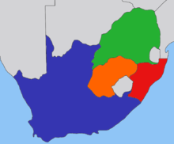
British territory (1899): Cape Colony (blue), Natal (red); Boers: Transvaal (green), Orange State

We also talked about the Japanese attempt to impose their own language and culture on Korea, which they ruled from 1910 to 1945 and where Chris worked for several years until `head-hunted’ by the HK school he now works for. Duncan mentioned Korean-American author Linda Sue Park’s novel When My Name was Keoko, which deals with this issue. The book can be previwed at:
http://www.amazon.com/When-My-Name-Was-Keoko/dp/0547722397

Coming on top of a long history of Korean resistance to Japanese power in earlier centuries, including Admiral Yi Sun-sin’s naval vistory at the end of the 16th century, this colonial period has resulteed in continuing tension between Korea and Japan, seen again recently over commemoration of the assasination of the Japanese prime minister by a Korean nationalist in Harbin in 1909.

There was also some talk about the Korean coutryside and about burial sites, Tanya, who married into a Korean family, mentioning her recent visit to the Lee clan’s cemetery

Tanya is currently organising a drama project for school children about the fighting in 1899 between the British army and some of the inhabitants of the New Territories (particularly from the Kam Tin area where she herself lives) after Britain took over administration of the region under the 1898 lease. Resistance was partly based on the mistaken belief that the British would impose restrictions they already enforced in urban areas and concern among village elites that they would lose land revenue. The episode is treated in depth in Pat’s book The Six-Day War of 1899 and he has organised and led tours of the main battle sites.
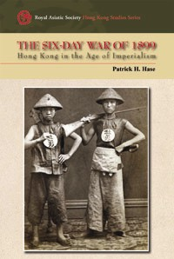
Details of the book are available at:
http://www.hkupress.org/Common/Reader/Products/ShowProduct.jsp?Pid=1&Version=0&Cid=16&Charset=iso-8859-1&page=-1&key=9789622098992 There I also a lot of contemporary information available in the archives section of the Legco website which includes records going back to 1841. See http://www.legco.gov.hk/general/english/sec/lc_archives/lc_archives_holding.htm

Towards the end of the meal we took turns reading sections form Terentius Tunberg’s account of the 2010 Conventiculum Lextōnianum, which was sent to all members of the Circuls earlier. The text is now also available with the embedded YouTube video on one page:
http://linguae.weebly.com/conventiculum-lexintonianum.html

Reckoned as the founder of the Zhou dynasty, though it was his son, 周武王 (Zhou Wu Huang), who actually overthrew the Shang dynasty.
Brother of Zhou Wu Hang and later regent for Wu’s son.
Iānsenistae - quī nomen dūxerant a Cornēliō Iānseniō (1585-1638), Iprēnsī epīscopō - saeculō 17ō in Galliā praecipuē flōruērunt, acriterque in Iēsuītās tamquam hypocritās, ambitiōsōs, Pelagiānos invectī sunt.

