Veterēs morbōrum cūrātiōnēs
Cum altera cachinnāns adnuisset, Phrygia, cōnservae adsēnsū ēlāta, tamquam magister ex cathedrā adiēcit haec:
`Herbīs enim eā aetāte morbī omnēs cūrābantur, vel quōrundam animālium adipe, vel etiam pāne, melle, oleō, acētō. An putās mē, hāc aetāte anum, quōmodō morbī cūrentur prōrsus ignōrāre? Meminī mē, cum huius familiae puerī interdum lippitūdine labōrārent, illōrum oculōs violīs atque crocō cūrāre, in aquā ex imbre collectā cum myrrhae grānulō incoctīs. Trīduum nōn interat: morbus tōtus aberat. Quid opus est medicīs? Num pūrulenta vulnera aptius cūrantur quam sī asphodelī folia impōnās? Dentēs putrēscere coepērunt: cōtīdiē māne salem sub linguā continē, dōnec liquēscat; nōn iam putrefīent. Dentium dolōre labōrās? Cucurbitae carnēs, absinthiī sūcō ac salis mīcīs immixtīs,hunc dolōrem penitus tollent. Maius dīcam: dentēs dolōre immūnēs fīent sī quis illōs quotannīs testūdinis sanguine colluere cōnsuēverit. Huius familiae servulus morbō rēgiō quondam labōrābat; sināpī in cucumeris sūcō īnfūsum illum exsorbēre iussī: medicāmentum parāveram, manibus ipsa meīs pōculum praebuī. Quid plūra? Tam citō ille ad sānitātem revertit, ut nē haedī quidem adeō sint alacrēs.’

Cicerō convalēscit
Per aliquot continuōs diēs Cicerō graviter aegrōtāvit; nec interdiū nec noctū febris remittēbātur. Sollicitī parentēs illum absurda verba ēdentem audiēbant: `Lamia adest’, dēlirāns clāmitābat, `apage illam, māter! Canem domesticum, pater, copulā vincitō: ingentēs illīus ex humerīs alae prōveniunt. En advolat, mē miserum: omnēs passerculōs in ipsō āere vorāvit.’
Febrī tandem carēre coepit. At inquīrentī mātrī morbī causa iam apertissimē patuerat; nam cum Cicerō ventrī ac gutturī nimis servīre cōnsuēvisset, ac saepe, clam parentibus et ispīs servīs, cibīs ad concoquendum difficilibus sē ingurgitāret, iamdūdum crūditāte laborāre coeperat. Iēiūnia illum ad sānitātem redēgērunt, nōn medicī.
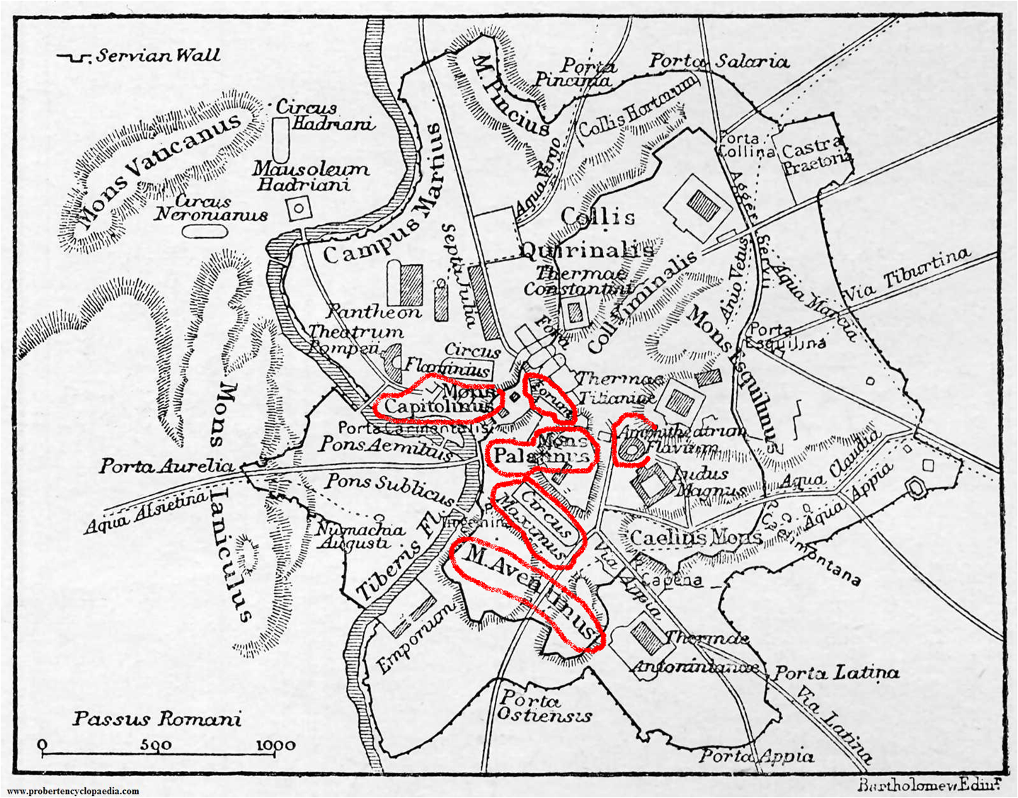
urbs Rōma c. annō 100 post Christum nātum; aevō Cicerōnis nōndum aedificātum erat Amphitheātrum Flaviānum (Colosseum)

Dē M. Cicerōnis domō in colle Palātīnō
Saepius Cicerō Marcum, patrem suum, cum Terentiā uxōre colloquentem audīvit, cum dīceret: `Rōmae equidem nūllās prīvātās aedēs hīs nostrīs pulchriōrēs esse arbitror.
M. Crassī haec domus ante fuit, virī et eloquentiā īnsignis et exquīsitissimō in omnibus rēbus iūdiciō; cui tam bene habitantī quis tum nōn invīdit? Neque immeritō; nihil enim hīc dēsīderātur. In Palātīnō colle haec domus aedificāta est, ubi omnēs fere Rōmānōrum prīncipēs, reīpūblicae regendae perītī, domicilium habent. Hinc forum adiacet, ex alterā parte Circus. Medium Rōmae locum habitāmus, nec quicquam, sī Capitōlium excēperis, in hāc urbe nōbilius habētur. Permagnō, fateor, hās aedēs ēmī; tantī mihi cōnstitērunt, ut nūlla suburbāna vīlla, sit licet ampla et sūmptuōsa, cārior sit. Mē tamen hās aedēs ēmīsisse nunquam paenitēbit.’

Parietēs, camerae, pavīmenta
In M. Cicerōnis domō omnia nītēbant. Parietum aliī pictī erant, aliī marmoreīs crustīs distinctī; camerae vērō laqueāribus (quae etiam lacūnāria dīcēbantur) exōrnātae erant aurō obtēctīs, saepe etiam ebore variātīs. Singula laqueāria tamquam figūram quadrātam marginibus efficiēbant, cuius pars media locus dīcēbātur. Hunc locum vel parvīs pictūrīs vel ōrnāmentīs ex gypsō artificēs complēverant. Nec minor erat pavīmentōrum splendor, quae ita tessellīs ad variārum rērum effigiem strūcta erant, ut hīc flōrēs exhibērent, illic avēs vel piscēs vel arborēs cum ipsīs frūctibus vel hūmānās faciēs, Tessellae plērumue ex sectō marmore factae erant, interdum ex vitrō vel ex onyche vel etiam ex aurō. Haec omnia ille parvulus Cicerō laetus mīrābātur, iam inde ā puerō luxuriae et ēlegantiae cupidus.

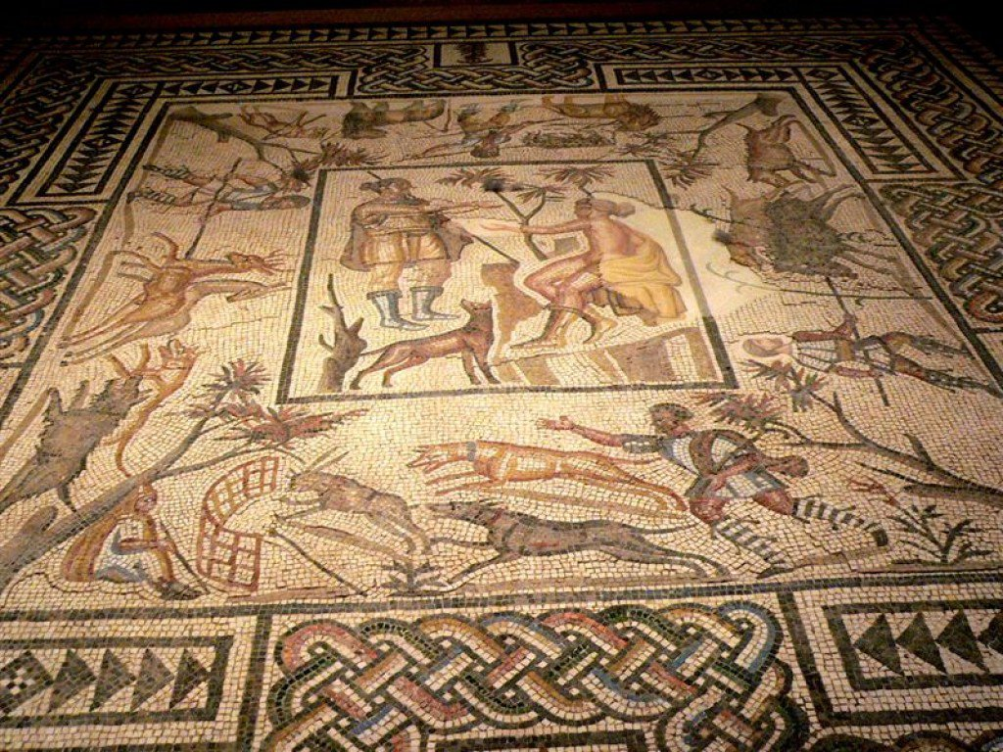
Pavīmentum saeculō tertiō post Chr. nātum Villalaurī (Villelaure) in Galliā cōnstructum
http://www.getty.edu/publications/romanmosaics/catalogue/excavations-villelaure/

`Nōsce tē ipsum’
Ūnam tantam figūram in triclīniī pavīmentō aequō animō spectāre nōn poterat oculōsque ab illā pavēscēns avertēbat; nam tessellāriī corpus ibi nūdīs ossibus cohaerēns effīnxerant rogō impositum, nigribus quibusdam uncīsque lineīs pyrae flammās simulantibus, nigrum ipsum et membra horrendum in modum distorquēns. Subter id Graecīs litterīs īnscriptum erat: ‘Nōsce tē ipsum.’ Sapientis enim Rōmānī putābant in ipsā
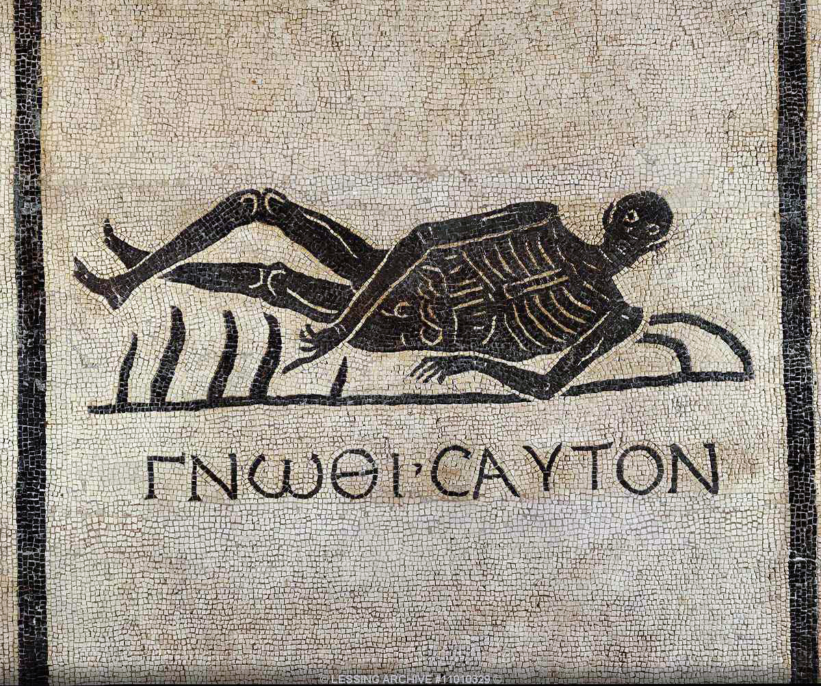
http://www.thehistoryblog.com/archives/41874
Museum Nationale Romanum, Palatium Maximum ad Thermas

convīviōrum laetitiā moriendī necessitātem nōn oblivīscī. At Cicerōnis fīlius ubi prīmum Graecum sermōnem discere coepit et Graecum illum titulum Latīnē vertere potuit: `Cibī fastidium,’ inquit, `iniciunt ista: mēmetipsum equidem ignōrāre mālō, quam languentī stomāchō convīviīs adesse.’

Dē Rōmānōrum lectīs
In domesticō M. Cicerōnis supellectile nihil pretiōsius erat qam lectī et mēnsae. Lectōrum apud Rōmānōs multa genera erant. Lectus cubiculāris is dīcēbātur quī in cubiculīs erat, dormientibus vel cubantibus aptus; quī in triclīniīs triclīniāris; aliī aliō nōmine indicābantur. Sī quis litterārum studiīs dēditus erat, lectō lūcubrātōriō ūtēbātur, ubi per multās hōrās quiēscendō meditārī posset vel legere vel aliquid in tabellīs adnotāre. Id
omnibus lectīs commūne erat quod pedēs spondam, fasciae vel lōra (īnstitae dīctae) culcitās sustinēbant.
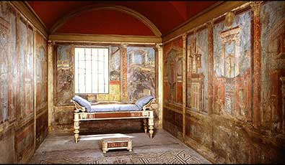
lectus cubiculāris in vīllā Rōmānā
http://www.furniturestyles.net/ancient/homes/roman-bedrooms.html

Dē lectōrum partibus
Sponda ligneum quoddam firmāmentum, quattuor vel sex pedibus fultum, obtentīs īnstitīs torōs et culcitās sustinēns. Bīna adminicula singulīs spondīs adnītēbantur, quōrum alterum, super iacentis caput ēminēns, fulcrum dīcēbātur, alterum, parietem obtegēns, pluteus. In dīvitum aedibus lectōrum pluteī et fulcra, ex pretiōsīs lignīs cōnfecta, aureīs et eburneīs lāminīs ōrnābentur.Torīs et culcitīs strāgula vestis insternēbātur, Īnstrātō lectō lintea vestis circumdūcēbātur, cui nōmen toral erat. Pauperum lectī, grabātī dictī, fulcrō et pluteō carēbant.
Pulvinīnīs quoque Rōmānī ūtēbantur, nec ōlum in lectīs, sed etiam in sedīlibus, nec sōlum adcaput fulciendum, sed etiam ut triclīnāria loca distinguerent. Pulvīnī quadrātīs strāgulīs fīēbant, tōmentō replētīs. Pulvīnus dormientis caput sustinēns cervical dīcēbātur

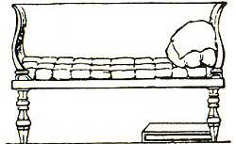
lectus cubicūlāris, fulcrīs pluteōque īnstructus (caelātūrā in Musaeō Britannicō)
https://archive.org/stream/illustratedcompa00richuoft#page/374/mode/2up)

vetus, verteris, old; cūrātiō, -ātiōnis f treatment
cachinnō, -āre, -āvī, chuckle, cackle; adsēnsus, -ūs n, agreement; ēlātus, -a, -um, elated, exalted (p.p. from efferō, effere, ēxtulī, ēlātum).
cathedra, -ae f (teacher’s) chair
quōrundam animālium adipe :`with the fat of certain animals’
mel, mellis n, honey; oleum, -ī n, oil, acētum, -ī n, vinegar; anus, -ūs f, old woman
prōrsus, utterly; interdum, sometimes; lippitūdō, lippitūdinis f, having watery eyes; labōrō ,be in difficulty, suffer, work.
viola, -ae f, violet; imber, imbris m, shower, rain.
incoquō, -re, -conquī, -coctum, boil (down); trīduum, -ī n, three-day period; intersum, come inbetween; Quid opus est medicīs?: `What’s the need for doctors?’ (literally `what’s the work with’); pūrūlentus, -a, -um, festering,.
aptius, more suitably; asphodelus, -ī m, asphodel (lily-like plant); folium, -ī n, leaf; putrēscō, -ere, rot; coepī, coepisse, began (defective verb with only perfect tenses).
cōtīdiē, daily; māne, in the morning; sal, salis m, salt; contineō, -ēre, -tinuī, -tentum, contain, keep; dōnec, until.
cucurbitae carnēs, absinthiī sūcō ac salis mīcīs immixtīs: the flesh of a pumpkin, with wormwood juice and grains of salt mixed in.’ Wormwood is a common herb (Artemisia absinthium) used in alcoholic drinks (especillty the spirit absinthe) and believed by some to be effective aganst digestive disorders and even cancer. penitus, completely.
tollō, -ere, sustulī, sublātum, raise up, remove ; maius, greater, more (neuter comparative of magnus); fīent , `will become’ (future of fiō, fierī, factus sum); quotannīs, every year; testūdō, testūdinis f, tortoise.
colluō, -ere, wash, rinse out; cōnsuēscō, -ere, -suēvī, -suētum, become accustomed to; morbus (-ī m) rēgius, jaundice.
sināpī, sināpis n, mustard; cucumis, cucumeris m, cucumber; exsorbeō, -ēre, -sorbuī, suck up.
ne..quidem, not even; haedus, -ī m, kid, young goat.
aegrōtō, -āre, -āvī, be sick; interdiū, in the daytime
remittō, -ere, -mīsī, -missum, send back, reduce.sollicitus, -a, -um, worried; lamia, -ae f, witch
apage, away with; copula, -ae f, chain; vinciō, vincīre, vīnxī, vīnctum, tie up, bind (distinguish carefully from vincō, vincere, vīcī, victum, defeat).
(h)umerus, -ī m, shoulder; ala, -ae f, wing; en, see!, behold!; advolat, flies towards; passerculus, -ī m, sparrow.
vorō (1), devour, engulf
careō, -ēre, caruī, be without (plus ablative); apertissimē, very openly
pateō, -ēre, -uī, be open, be revealed; ventrī … cōnsuēvisset, `had become accustomed to indulging stomach and throat too much’; clam, secretly, without the knowledge of
concoquō, -ere, -coxī, -coctum, digest; ingurgitō (1), fill, glut; iamdūdum, long ago
crūditās, -itātis f, indigestion; iēiūnia, -ae f, fasting; redigō, -ere, -ēgī, -āctum, drive back, return
collis/mōns Palātīnus (also Palātium): the hill on which Romulus is said to have founded the city and which was an elite residential area under the Republic. Under the Principate the whole area was taken over by the imperial family, hence the derivation from its name of English `palace.’
Referring to Marcus Licinius Crassus, reputedly the richest man in Rome, who had been Pompey and Caesar’s ally in the informal `First Triumvirate’ and was to die fighting the Parthians in 53 B.C. Cicero bought the house in 62 B.C., when his son was already 3 years old, for 3.5 million sesterces (see (http://penelope.uchicago.edu/Thayer/E/Gazetteer/Places/Europe/Italy/Lazio/Roma/Rome/_Texts/PLATOP*/Domus_Ciceronis.html), going heavily into debt to do so.
exquīsitissimō…iūdiciō, ablative of description qualifying virī; invideō, -ēre, -vīdī, -vīsum, envy, be jealous
reīpūblicae regendae perītī: `skilled in governing the state’ (literally `of the state being governed’; the Romans preferred this gerundive construction to the gerund with direct object (rempūblicam gerendī), which would be closer to the English idiom
permagnō, at a very great price; fateor, -ērī, fassus sum, speak, declare; tantī (genitive of value) so much; cōnstitērunt is perfect of cōnstō, -āre, cost, consist, be agreed) not of cōnsistō, -ere, cōnstitī, cōnstitum, stand together, cease, consist (of)
The first sit is subjunctive because it is in a concessive clause with licet (`although’, literally `is permitted’), the second one because it is in a result clause: `[the house] cost me so much that no suburban villa, though it be large and luxurious, is more expensive’; ēmīsisse, to have bought.
paenitet, -ēre, -uit, be a cause of regret.
niteō, -ēre, -uī, gleam, shine; marmoreus, -a, -um, of marble
camera, -ae f, room; crusta, -ae f, stucco-work, shell, crust; lacūnar, lacūnāris n, (synonym of laquear, laqueāris n), ceiling panel formed by interlocking wooden rafters or by masonory in imitation of woodwork (see The Illustrated Companion to the Latin Dictionary. https://archive.org/stream/illustratedcompa00richuoft#page/398/mode/2up )
obtegō, -ere, -tēxī, -tēctum, cover’; ebur, eboris n, ivory; variō (1), mark in different figures
`Singula …efficiēbant: `individual panels produced with their edges [something] just like a square shape’
gypsum, -ī n, gypsum, white lime plaster,
compleō, -ēre, -plēvī, -plētum, fill (up)
tessella (tessera), -ae f, small square piece of stone; struō, struere, strūxī, strūctum build, construct
secō, secāre, secuī, sectum, cut (up); vitrum, -ī n, glass; onyx, onychis m/f, onyx, yellow marble
iam inde ā puerō: `already from boyhood’
pavēscō, -ere, become alarmed; tessellārius, -ī m, mosaic maker; os, ōssis n, bone; cohaerēns, forming a whole, sticking together
effingō, -ere, -fīnxī, -fictum, represent, portray; rogus, -ī m, pyre; impōnō, -ere, -posuī, -positum, place upon;
nigris…simulantibus: `with certain black, curved lines imitating the flames of the pyre’ (Latin normally needs et or -que to join together two adjectives qualifying the same noun.
ipsum refers back to corpus; subter, underneath
`Nosce tē ipsum’: `know thyself’; Sapientis…esse, `that it was the mark of a wise man’
convīvium, -ī n, feast, party; laetitia, -ae f, happiness, joy; morior, morī, mortuus sum, die; oblivīscor, oblivīscī, oblītus sum, forget
fastidium, -ī n, squeamishness, loathing; iniciō, -ere, -iēcī, -iectum, throw in, induce; mēmetipsum, myself (emphatic form of the reflexive); mālō,mālle, māluī , prefer; languēns, -entis, becoming weak.
supellex, supellectilis f, furniture; pretiōsus, -a, -um, precious.
cubō (1), lie down; quī in triclīniīs, `the one which [is] in dining-rooms’
Sī quis…deditus erat: `if anyone was devoted to studies’; dēdō, dēdere, dēdidī, deditum, surrender, yield; lūcubrātōrius, -a, -um, belonging to a night student.
posset: subjunctive in purpose clause introduced by ubi.
sponda,-ae f, bed-frame; fascia, -ae f, band, bandage; lōrum, -ī n, strap (of leather); īnstita, -ae f, band (on dress or bed); culcita, -ae f, mattress, cushion.
iacentis (present participle from iaceō): `of the person lying down’; ēmineō, -ēre, -uī, stick out; fulcrum, -ī, n, support especially at the end of a couch, also known as an anaclintērium (there was often a second fulcrum at the opposite end of the bed, as in the coloured illustration;
pluteus, -ī m, side board on a bed, shelf (many beds did not in fact have this),

